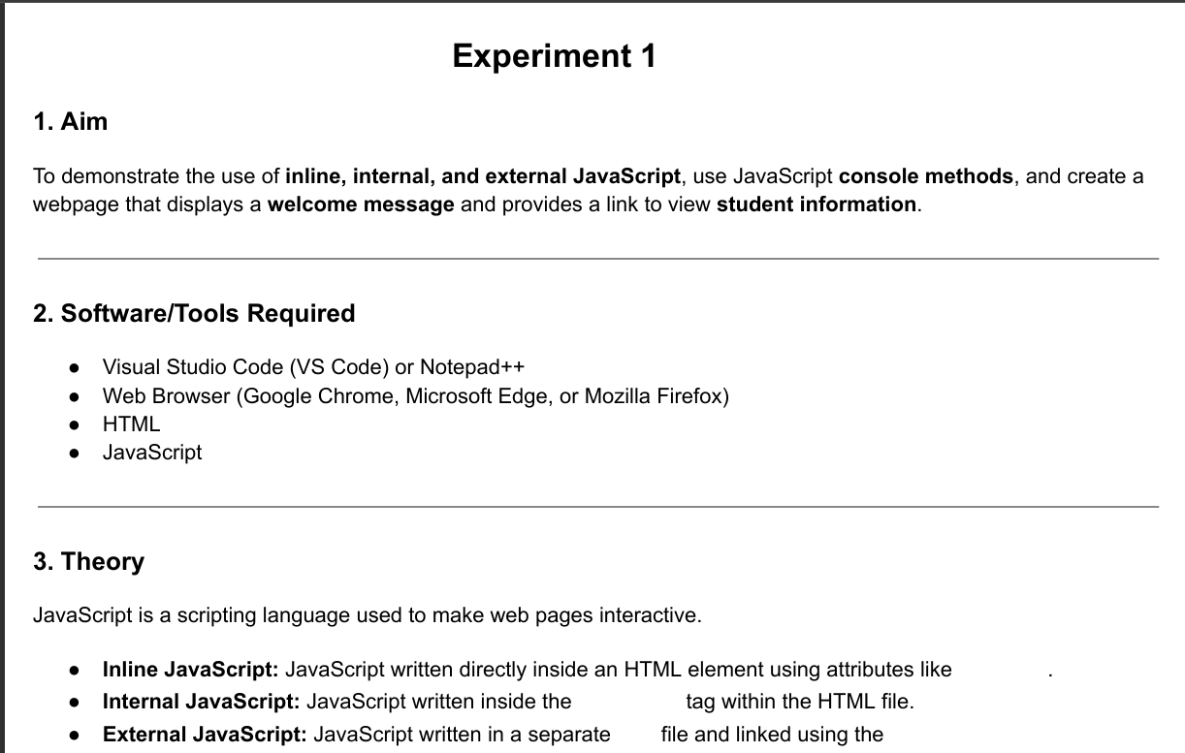
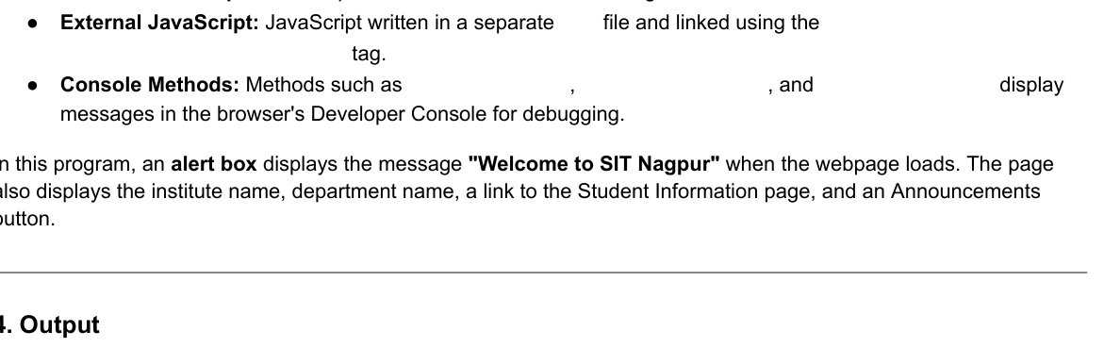
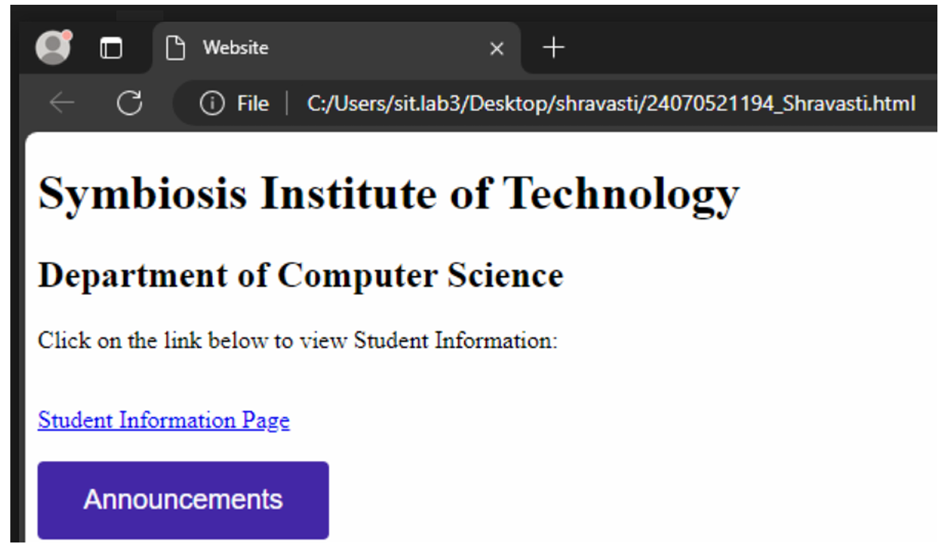
Case study 1
📝 1. Aim
To design and develop a responsive webpage for a college department using HTML and CSS, and to integrate JavaScript to display a welcome alert message upon page load while dynamically linking and fetching student information.

📚 2. Theory
Building an interactive portal requires a structured separation of concerns between front-end content layout, presentation aesthetics, and behavioral programming:
- HTML5 (HyperText Markup Language): Formulates the backbone and structural architecture of the web page. It uses semantic tags (like <header>, <div>, and <section>) to host structural information like the college name, department details, and data search containers.
- CSS3 (Cascading Style Sheets): Controls the visual design, spacing, layout, typography, and color palette. Applying clean box models ensures that the UI looks highly organized, readable, and behaves responsively across multiple screen devices.
- JavaScript (Client-Side Scripting): Enables browser-side interactivity and logical compute powers:
  - window.onload Trigger: An event listener that executes instantly once the DOM tree completes loading. By embedding alert("welcome to sit nagpur"); inside this lifecycle hook, the browser pops open an interactive modal message box before structural interaction begins.
  - Data Objects and DOM Manipulation: Instead of hardcoding text, student profiles are stored structured inside a JavaScript Key-Value schema dictionary (studentDatabase). When the user inputs a parameter (like a Roll Number) and hits search, JS intercepts the event, queries the dataset, updates HTML text targets via document.getElementById(), and flips CSS display properties dynamically without forcing a full page reload.

Code :
<!DOCTYPE html>
<html lang="en">
<head>
<meta charset="UTF-8">
<meta name="viewport" content="width=device-width, initial-scale=1.0">
<title>SIT Nagpur - Computer Science Department</title>
<style>
* {
box-sizing: border-box;
margin: 0;
padding: 0;
font-family: 'Segoe UI', Tahoma, Geneva, Verdana, sans-serif;
}
body {
background-color: #f4f6f9;
color: #333;
line-height: 1.6;
}
header {
background-color: #1a365d;
color: white;
padding: 2rem;
text-align: center;
}
header h1 {
margin-bottom: 0.5rem;
}
.container {
max-width: 1000px;
margin: 2rem auto;
padding: 0 1rem;
}
.section {
background: white;
padding: 2rem;
border-radius: 8px;
box-shadow: 0 4px 6px rgba(0,0,0,0.05);
margin-bottom: 2rem;
}
h2 {
color: #2b6cb0;
margin-bottom: 1rem;
border-bottom: 2px solid #e2e8f0;
padding-bottom: 0.5rem;
}
.search-box {
display: flex;
gap: 10px;
margin-top: 1rem;
}
input[type="text"] {
flex: 1;
padding: 0.75rem;
border: 1px solid #cbd5e0;
border-radius: 4px;
font-size: 1rem;
}
button {
background-color: #2b6cb0;
color: white;
border: none;
padding: 0.75rem 1.5rem;
border-radius: 4px;
cursor: pointer;
font-size: 1rem;
font-weight: bold;
}
button:hover {
background-color: #1a365d;
}
.result-card {
margin-top: 1.5rem;
padding: 1rem;
background: #ebf8ff;
border-left: 4px solid #3182ce;
border-radius: 4px;
display: none;
}
.result-card p {
margin: 0.5rem 0;
}
.error-text {
color: #e53e3e;
margin-top: 1rem;
display: none;
}
</style>
</head>
<body>

<!-- Header Section -->
<header>
<h1>Symbiosis Institute of Technology (SIT), Nagpur</h1>
<p>Department of Computer Science & Engineering</p>
</header>

<div class="container">
<!-- About Department Section -->
<div class="section">
<h2>About the Department</h2>
<p>Welcome to the Department of Computer Science & Engineering at SIT Nagpur. We offer world-class infrastructure, industry-aligned research opportunities, and a cutting-edge curriculum tailored to prepare students for the global tech landscape.</p>
</div>

<!-- Student Information Portal Section -->
<div class="section">
<h2>Student Information Portal</h2>
<p>Enter a Student Roll Number to view academic profile and current department database alignment:</p>

<div class="search-box">
<input type="text" id="rollInput" placeholder="Try entering: SIT001 or SIT002">
<button onclick="searchStudent()">Search Profile</button>
</div>

<!-- Box to display results dynamically -->
<div id="resultBox" class="result-card">
<h3>Student Profile Found</h3>
<p><strong>Name:</strong> <span id="resName"></span></p>
<p><strong>Roll Number:</strong> <span id="resRoll"></span></p>
<p><strong>Current Semester:</strong> <span id="resSem"></span></p>
<p><strong>CGPA:</strong> <span id="resCgpa"></span></p>
</div>

<p id="errorBox" class="error-text">No student found matching that Roll Number. Please try again.</p>
</div>
</div>

<!-- JavaScript Segment -->
<script>
// 1. Mandatory requirement: Welcome Alert Box on Page Load
window.onload = function() {
alert("welcome to sit nagpur");
};

// Mock Database linking student info
const studentDatabase = {
"SIT001": { name: "Aarav Sharma", sem: "4th Semester", cgpa: "8.9" },
"SIT002": { name: "Ananya Iyer", sem: "6th Semester", cgpa: "9.4" },
"SIT003": { name: "Kabir Verma", sem: "2nd Semester", cgpa: "7.8" }
};

// 2. Interactive Search Logic linking the UI to the Student Information Object
function searchStudent() {
const inputVal = document.getElementById("rollInput").value.trim().toUpperCase();
const resultBox = document.getElementById("resultBox");
const errorBox = document.getElementById("errorBox");

if (studentDatabase[inputVal]) {
// Populate data
document.getElementById("resName").innerText = studentDatabase[inputVal].name;
document.getElementById("resRoll").innerText = inputVal;
document.getElementById("resSem").innerText = studentDatabase[inputVal].sem;
document.getElementById("resCgpa").innerText = studentDatabase[inputVal].cgpa;

// Toggle view states
resultBox.style.display = "block";
errorBox.style.display = "none";
} else {
// Hide data cards and display error text
resultBox.style.display = "none";
errorBox.style.display = "block";
}
}
</script>
</body>
</html>

Output :

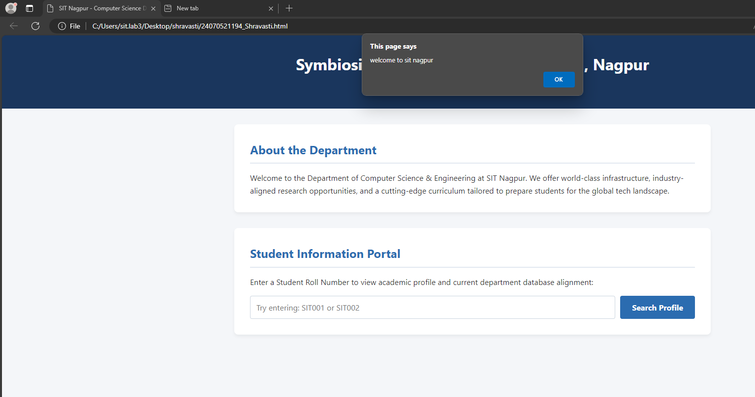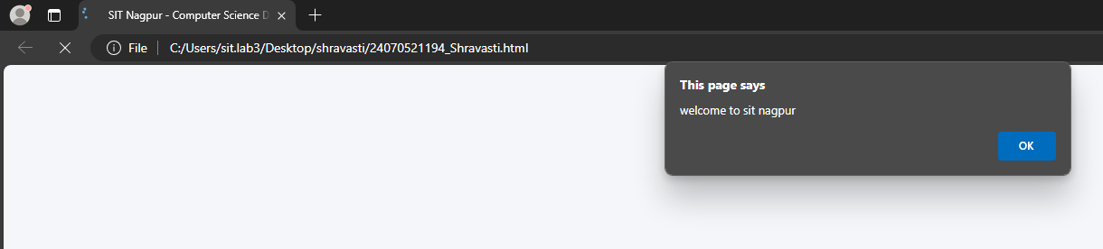
🏁 3. Conclusion
The objective of creating an interactive college department portal was successfully accomplished. The webpage efficiently displays department details, triggers the designated client-side welcome alert banner upon system initialization, and enables seamless, instantaneous matching of student query datasets. This structure showcases how simple client-side Javascript scripts can be paired with standard HTML/CSS structure to build highly functional user interfaces.

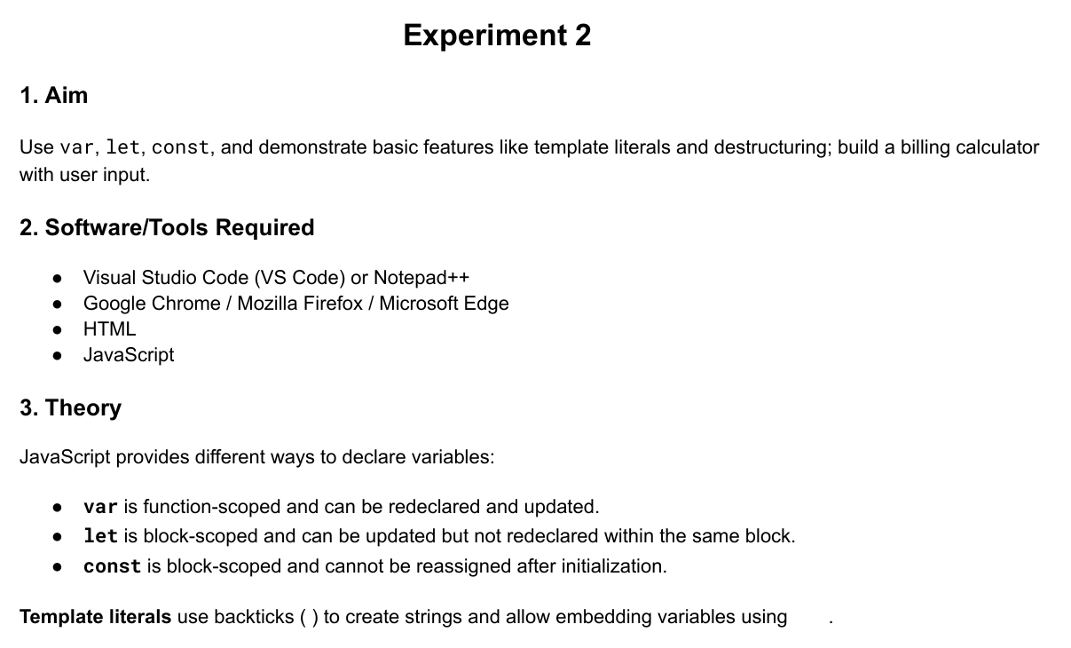
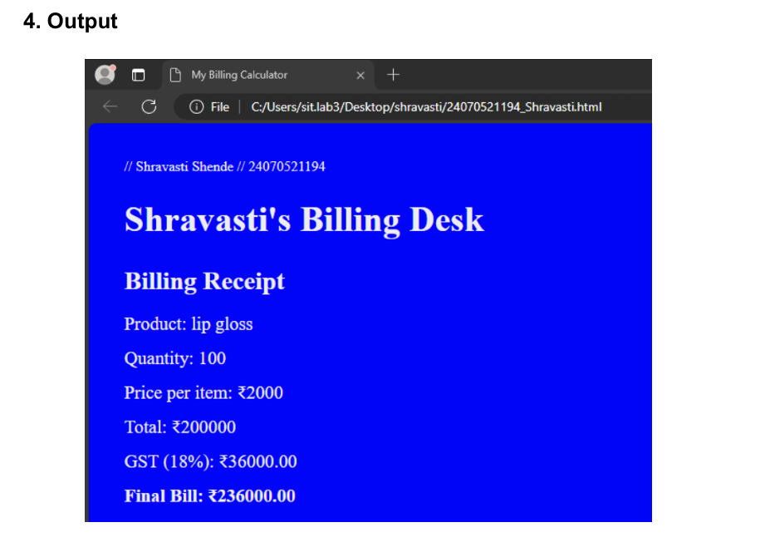
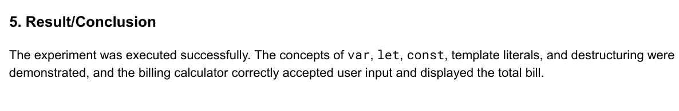
Case study 2

📝 1. Aim
To design and implement a responsive text-based Retail Invoice Billing Terminal using HTML5, CSS3, and JavaScript that captures customer data (Name and Phone Number) alongside dynamic product inputs (Name, Price, and Quantity) to compute and display a live paper-style receipt layout.

📚 2. Theory
Developing digital transaction desk software requires programmatic coordination between form input state management, algorithmic arithmetic operations, and real-time DOM structure rendering:
- Semantic Form Handlers (HTML5): Formulates text capturing blocks using <input> elements tied to concrete statistical metrics (type="text", type="number"). These controls accept explicit customer metrics and store unit costs securely before compilation.
- Monospaced Aesthetic Presentation (CSS3): By enforcing strict typographical styling rules via font-family: 'Courier New', monospace;, the web layout takes on the structured formatting signature of legacy thermal cash registers. A clean side-by-side flexbox configuration maps input fields on the left and the paper receipt output terminal cleanly on the right.
- Dynamic Data Pipelines & Arithmetic Engine (JavaScript):
  - Real-time Event Listeners: By attaching the oninput hook directly to identity tracking boxes, user keystrokes dynamically stream client attributes straight onto the billing header matrix.
  - Array Storage & Aggregate Math Logic: Individual product objects are continuously structured and appended into a centralized dynamic storage matrix (billedItemsArray).
  - Tax Formulation Rules: The programming script iterates through the records array to compute product sub-totals, appends a standard combined 18% Goods and Services Tax (GST) block, and pushes formatted string nodes back onto target HTML node IDs without breaking active window focus.

Code :
<!DOCTYPE html>
<html lang="en">
<head>
<meta charset="UTF-8">
<meta name="viewport" content="width=device-width, initial-scale=1.0">
<title>Retail Invoice Billing Terminal</title>
<style>
* {
box-sizing: border-box;
margin: 0;
padding: 0;
font-family: 'Courier New', Courier, monospace; /* Text/Receipt style font */
}
body {
background-color: #f1f5f9;
color: #1e293b;
padding: 20px;
}
.container {
max-width: 900px;
margin: 0 auto;
display: flex;
gap: 20px;
}
/* Left Panel - Entry Form */
.form-section {
flex: 1;
background: white;
padding: 20px;
border-radius: 6px;
box-shadow: 0 4px 6px rgba(0,0,0,0.05);
}
/* Right Panel - Live Receipt */
.receipt-section {
flex: 1;
background: #fffdf0; /* Paper color */
padding: 25px;
border: 1px solid #cbd5e1;
border-radius: 4px;
box-shadow: 0 4px 10px rgba(0,0,0,0.05);
}
h2 {
font-size: 1.2rem;
margin-bottom: 15px;
text-transform: uppercase;
border-bottom: 2px solid #1e293b;
padding-bottom: 5px;
}
.form-group {
margin-bottom: 12px;
}
label {
display: block;
font-size: 0.85rem;
font-weight: bold;
margin-bottom: 4px;
text-transform: uppercase;
}
input {
width: 100%;
padding: 8px;
border: 1px solid #94a3b8;
border-radius: 4px;
font-size: 0.9rem;
font-family: inherit;
}
button {
width: 100%;
background-color: #1e293b;
color: white;
border: none;
padding: 10px;
font-size: 0.9rem;
font-weight: bold;
cursor: pointer;
text-transform: uppercase;
margin-top: 10px;
font-family: inherit;
}
button:hover {
background-color: #334155;
}
/* Receipt Aesthetics */
.receipt-line {
display: flex;
justify-content: space-between;
margin-bottom: 6px;
font-size: 0.9rem;
}
.divider {
border-top: 1px dashed #475569;
margin: 12px 0;
}
.bold-text {
font-weight: bold;
}
.center-text {
text-align: center;
}
#itemsTable {
width: 100%;
margin: 10px 0;
font-size: 0.85rem;
}
#itemsTable th {
text-align: left;
border-bottom: 1px solid #1e293b;
padding-bottom: 4px;
}
#itemsTable td {
padding: 4px 0;
}
.empty-text {
text-align: center;
color: #64748b;
font-style: italic;
}
</style>
</head>
<body>

<div class="container">
<!-- Left Side: Order & Customer Input Controls -->
<div class="form-section">
<h2>1. Customer Details</h2>
<div class="form-group">
<label>Customer Name:</label>
<input type="text" id="custName" placeholder="Enter Full Name" oninput="updateReceiptMetadata()">
</div>
<div class="form-group">
<label>Phone Number:</label>
<input type="text" id="custPhone" placeholder="Enter Phone Number" oninput="updateReceiptMetadata()">
</div>

<h2 style="margin-top: 25px;">2. Add Product Items</h2>
<div class="form-group">
<label>Product Name:</label>
<input type="text" id="prodName" placeholder="e.g. Wireless Mouse">
</div>
<div class="form-group">
<label>Unit Price (₹):</label>
<input type="number" id="prodPrice" placeholder="e.g. 499">
</div>
<div class="form-group">
<label>Quantity:</label>
<input type="number" id="prodQty" value="1" min="1">
</div>
<button onclick="addProductItem()">Add Item to Bill</button>
<button onclick="resetBillSystem()" style="background-color: #ef4444; margin-top: 5px;">Clear Entire Bill</button>
</div>

<!-- Right Side: Clean Paper Text Invoice Summary Frame -->
<div class="receipt-section" id="receiptPrintArea">
<div class="center-text bold-text" style="font-size: 1.3rem;">SMART RETAILS LTD</div>
<div class="center-text" style="font-size: 0.8rem; margin-bottom: 10px;">Nagpur, MH, India</div>

<div class="divider"></div>

<!-- Customer Metadata -->
<div class="receipt-line">
<span>CLIENT NAME:</span>
<span id="recName" class="bold-text">--------</span>
</div>
<div class="receipt-line">
<span>PHONE NO :</span>
<span id="recPhone" class="bold-text">--------</span>
</div>
<div class="receipt-line">
<span>DATE :</span>
<span id="recDate"></span>
</div>

<div class="divider"></div>

<!-- Items Table Ledger Grid -->
<table id="itemsTable">
<thead>
<tr>
<th style="width: 45%;">ITEM</th>
<th style="width: 15%;">QTY</th>
<th style="width: 20%;">RATE</th>
<th style="width: 20%; text-align: right;">TOTAL</th>
</tr>
</thead>
<tbody id="receiptItemsBody">
<tr id="fallbackRow"><td colspan="4" class="empty-text">No items billed yet.</td></tr>
</tbody>
</table>

<div class="divider"></div>

<!-- Dynamic Balance Totals Row Configurations -->
<div class="receipt-line">
<span>SUBTOTAL:</span>
<span id="recSubtotal">₹0.00</span>
</div>
<div class="receipt-line">
<span>CGST + SGST TAX (18%):</span>
<span id="recTax">₹0.00</span>
</div>
<div class="receipt-line bold-text" style="font-size: 1.1rem; margin-top: 5px;">
<span>GRAND TOTAL:</span>
<span id="recGrandTotal">₹0.00</span>
</div>

<div class="divider"></div>
<div class="center-text bold-text" style="margin-top: 15px; font-size: 0.85rem;">*** THANK YOU FOR VISITING ***</div>
</div>
</div>

<!-- Core Interactive Operations Engine scripts -->
<script>
// Array keeping live context records active
let billedItemsArray = [];

// Stamp runtime instance localized timestamp
document.getElementById('recDate').innerText = new Date().toLocaleDateString('en-IN');

// Dynamically pass consumer metadata straight over to text view fields
function updateReceiptMetadata() {
const nameVal = document.getElementById("custName").value.trim();
const phoneVal = document.getElementById("custPhone").value.trim();

document.getElementById("recName").innerText = nameVal ? nameVal.toUpperCase() : "--------";
document.getElementById("recPhone").innerText = phoneVal ? phoneVal : "--------";
}

// Add user inputs safely into the array table matrix
function addProductItem() {
const name = document.getElementById("prodName").value.trim();
const price = parseFloat(document.getElementById("prodPrice").value);
const qty = parseInt(document.getElementById("prodQty").value);

// Primitive validation barriers
if (!name || isNaN(price) || price <= 0 || isNaN(qty) || qty <= 0) {
alert("Please check item fields. Name, valid price, and quantity are required.");
return;
}

// Push validation clear records down onto stack
billedItemsArray.push({
name: name,
price: price,
qty: qty,
total: price * qty
});

// Wipe specific structural text boxes clear for tracking the next record
document.getElementById("prodName").value = "";
document.getElementById("prodPrice").value = "";
document.getElementById("prodQty").value = "1";

// Run structural data node updates inside DOM tree
calculateAndRenderBill();
}

function calculateAndRenderBill() {
const tbody = document.getElementById("receiptItemsBody");
tbody.innerHTML = ""; // Clear table row elements

if (billedItemsArray.length === 0) {
tbody.innerHTML = '<tr id="fallbackRow"><td colspan="4" class="empty-text">No items billed yet.</td></tr>';
document.getElementById("recSubtotal").innerText = "₹0.00";
document.getElementById("recTax").innerText = "₹0.00";
document.getElementById("recGrandTotal").innerText = "₹0.00";
return;
}

let calculatedSubtotal = 0;

// Generate clean textual grid line records per loop entry match
billedItemsArray.forEach(item => {
calculatedSubtotal += item.total;

const tr = document.createElement("tr");
tr.innerHTML = `

Output
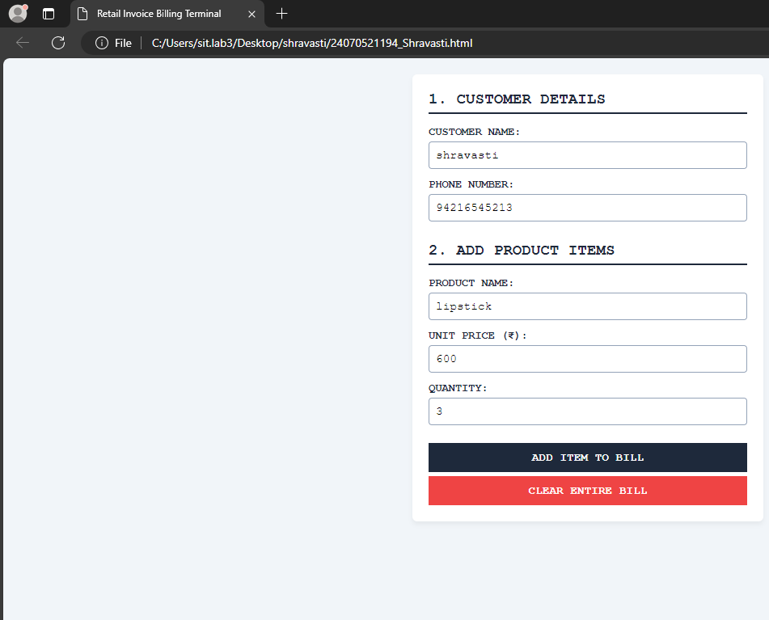
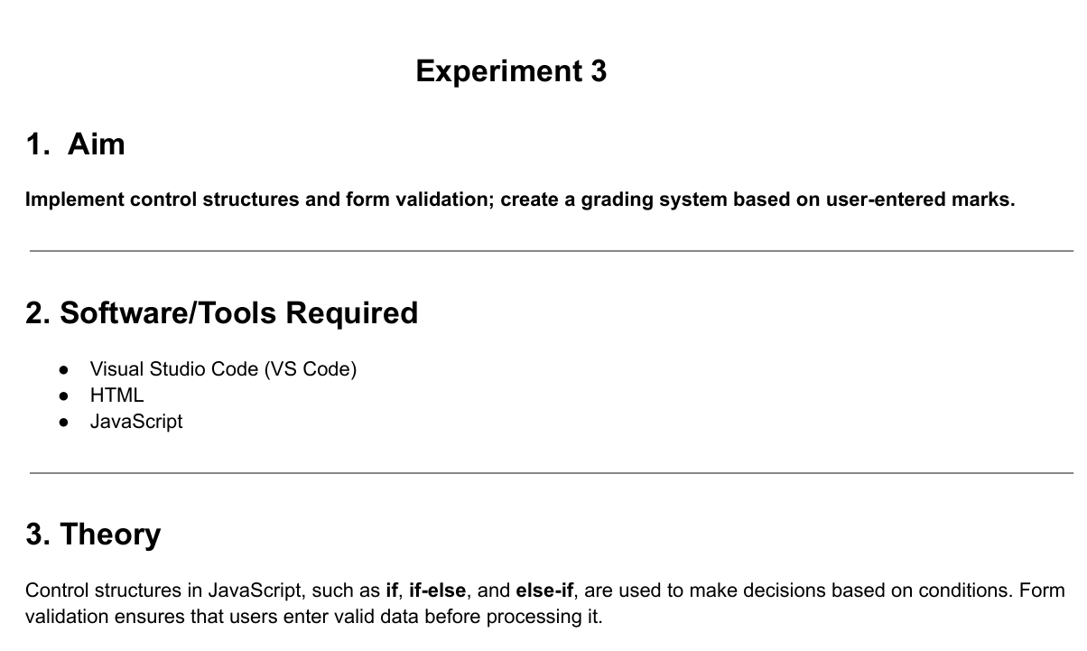
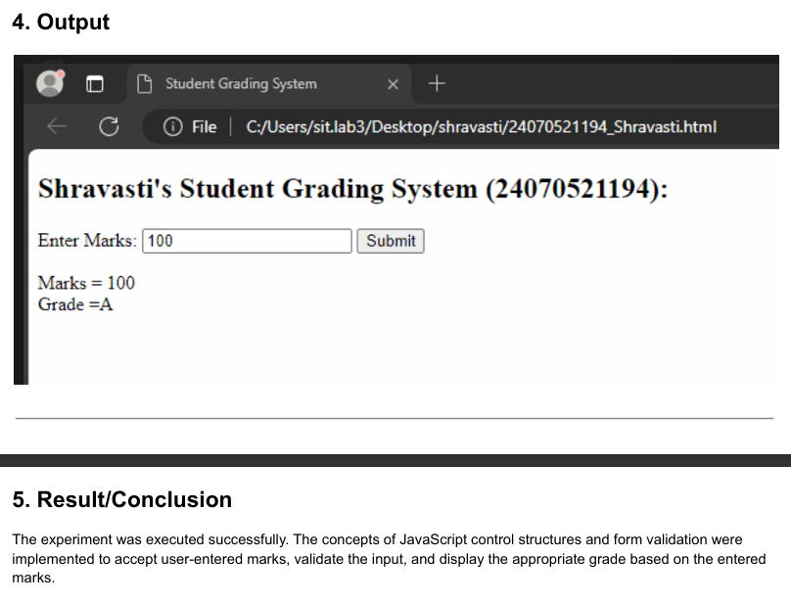
Case study 3
Aim :
📝 1. Aim
To design and implement a responsive single-page web utility using HTML5, CSS3, and JavaScript that instantly evaluates and displays whether a student is "Eligible" or "Not Eligible" for a scholarship based on their numerical percentage input.

📚 2. Theory
Building clean input validation tools requires structured communication between data collection nodes, design properties, and standard logic statements:
- HTML5 Data Capturing Block: Formulates the basic skeleton layout utilizing a numeric text entry element (type="number"). To restrict garbage data points at the foundational stage, constraints like min="0" and max="100" are declared.
- CSS3 Alert States Design: Implements clean box layouts to provide immediate visual feedback. The layout defines two specific context alert classes: a soothing green theme (.eligible) to represent a successful status match, and a soft red border container (.not-eligible) to represent a failed qualification bracket.
- JavaScript Conditional Matrix:
  - Data Parsing: The engine extracts structural text strings using document.getElementById().value and sanitizes the entry via the global parseFloat() method.
  - Binary Assessment Pipeline: It measures the captured values against a pre-set institution pass limit index (75%). Using a standard if-else control flow structure, the script updates the internal message string using innerText and dynamically modifies the CSS template classes via className to reflect the result instantly without a full page reload.

Code
<!DOCTYPE html>
<html lang="en">
<head>
<meta charset="UTF-8">
<meta name="viewport" content="width=device-width, initial-scale=1.0">
<title>Scholarship Eligibility Check</title>
<style>
* {
box-sizing: border-box;
margin: 0;
padding: 0;
font-family: 'Segoe UI', Arial, sans-serif;
}
body {
background-color: #f3f4f6;
display: flex;
justify-content: center;
align-items: center;
min-height: 100vh;
padding: 20px;
}
.card {
background: white;
padding: 30px;
border-radius: 8px;
box-shadow: 0 4px 10px rgba(0,0,0,0.08);
max-width: 400px;
width: 100%;
text-align: center;
}
h2 {
color: #1e3a8a;
margin-bottom: 20px;
font-size: 1.5rem;
}
.form-group {
margin-bottom: 20px;
text-align: left;
}
label {
display: block;
font-size: 0.9rem;
font-weight: bold;
color: #4b5563;
margin-bottom: 6px;
}
input {
width: 100%;
padding: 10px;
border: 1px solid #d1d5db;
border-radius: 4px;
font-size: 1rem;
outline: none;
}
button {
width: 100%;
background-color: #2563eb;
color: white;
border: none;
padding: 12px;
font-size: 1rem;
font-weight: bold;
border-radius: 4px;
cursor: pointer;
}
button:hover {
background-color: #1d4ed8;
}
.result-box {
margin-top: 20px;
padding: 15px;
border-radius: 4px;
font-weight: bold;
font-size: 1.1rem;
display: none; /* Hidden by default */
}
.eligible {
background-color: #d1fae5;
color: #065f46;
border: 1px solid #34d399;
}
.not-eligible {
background-color: #fee2e2;
color: #991b1b;
border: 1px solid #f87171;
}
</style>
</head>
<body>

<div class="card">
<h2>Scholarship Portal</h2>

<div class="form-group">
<label>Enter Your Total Marks Percentage (%):</label>
<input type="number" id="studentMarks" placeholder="e.g. 82" min="0" max="100">
</div>

<button onclick="checkEligibility()">Check Eligibility</button>

<!-- Live Status Box Output -->
<div id="statusResult" class="result-box"></div>
</div>

<script>
function checkEligibility() {
// Get value from input box
const marks = parseFloat(document.getElementById("studentMarks").value);
const resultBox = document.getElementById("statusResult");

// Validation guard check
if (isNaN(marks) || marks < 0 || marks > 100) {
alert("Please enter a valid percentage between 0 and 100.");
resultBox.style.display = "none";
return;
}

// Reveal result box container
resultBox.style.display = "block";

// Conditional eligibility check (Passing criteria: 75% or higher)
if (marks >= 75) {
resultBox.innerText = "🎉 ELIGIBLE FOR SCHOLARSHIP";
resultBox.className = "result-box eligible";
} else {
resultBox.innerText = "❌ NOT ELIGIBLE FOR SCHOLARSHIP";
resultBox.className = "result-box not-eligible";
}
}
</script>
</body>
</html>

Output
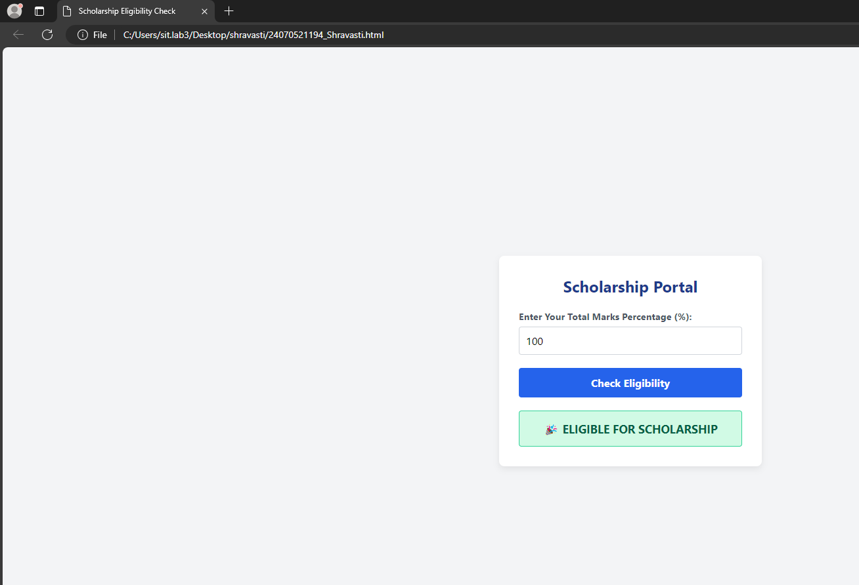

🏁 3. Conclusion
The development of the streamlined Scholarship Eligibility Portal was completed successfully. The application accurately captures numerical student grading percentages, executes client-side safety evaluation checks, and outputs clear binary outcomes ("ELIGIBLE" vs. "NOT ELIGIBLE"). This project demonstrates the practical usage of basic form control conditions to automate student evaluation workflows efficiently.

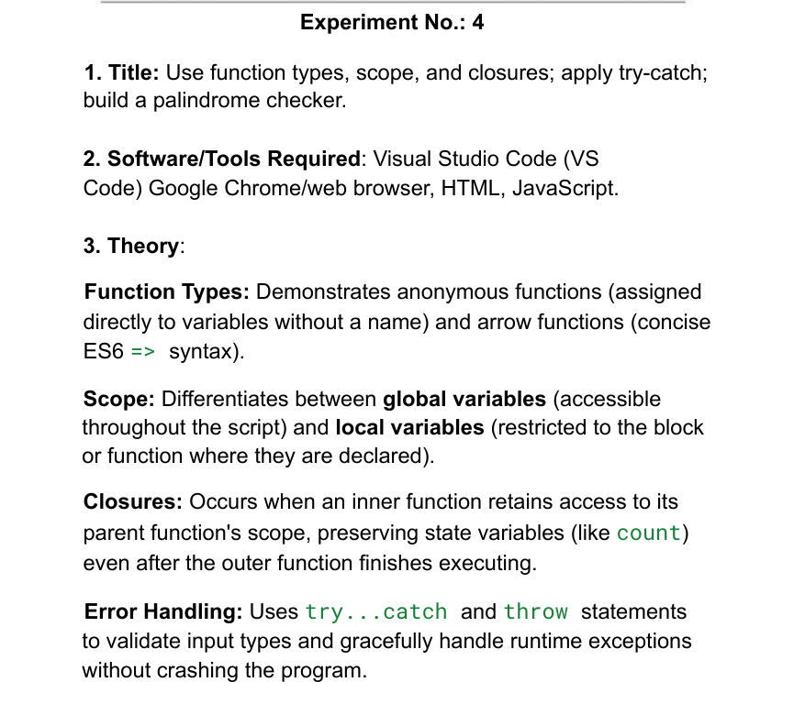
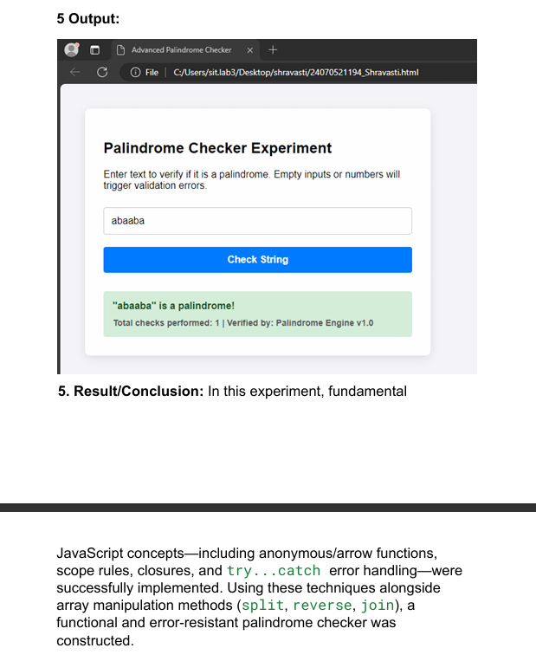
Case Study 4
Aim
To create a responsive single-page web application using HTML5, CSS3, and JavaScript that takes a numerical input from the user and dynamically verifies whether the entered number is a palindrome or not.

Theory & Logic Implementation
- HTML5 Architecture: A simple container input card holds a numeric text entry element (type="number") to restrict non-numeric alphabetic keyboard characters at the entry point.
- CSS3 Visual Indicators: Two unique layout feedback classes are defined to give the user immediate visual clarity: a light green success banner (.is-palindrome) and a soft crimson error container (.not-palindrome).
- JavaScript Algorithmic Engine:
  - Extraction: The values are pulled into memory dynamically using document.getElementById().value.
  - String Reversal Method: The number is converted into a standard text string. The script chains built-in array utilities to flip the digits: .split('') breaks the number into individual digits, .reverse() mirrors the array order, and .join('') binds them back together.
  - Strict Equality Evaluation: An if-else condition compares the original number string directly against the newly reversed string. If they match identically, the script alters the inner text and injects the green CSS layout class.

💻 5. Complete Source Code (palindrome.html)
<!DOCTYPE html>
<html lang="en">
<head>
<meta charset="UTF-8">
<meta name="viewport" content="width=device-width, initial-scale=1.0">
<title>Case Study: Palindrome Checker</title>
<style>
* {
box-sizing: border-box;
margin: 0;
padding: 0;
font-family: 'Segoe UI', Tahoma, Geneva, Verdana, sans-serif;
}
body {
background: linear-gradient(135deg, #e0eafc 0%, #cfdef3 100%);
display: flex;
justify-content: center;
align-items: center;
min-height: 100vh;
padding: 20px;
}
.case-study-card {
background: white;
padding: 35px;
border-radius: 12px;
box-shadow: 0 10px 25px rgba(0,0,0,0.08);
max-width: 450px;
width: 100%;
text-align: center;
}
h2 {
color: #2c3e50;
margin-bottom: 8px;
font-size: 1.6rem;
}
p.subtitle {
color: #7f8c8d;
font-size: 0.9rem;
margin-bottom: 25px;
}
.form-group {
margin-bottom: 20px;
text-align: left;
}
label {
display: block;
font-size: 0.85rem;
font-weight: bold;
color: #34495e;
margin-bottom: 6px;
text-transform: uppercase;
}
input {
width: 100%;
padding: 12px;
border: 2px solid #bdc3c7;
border-radius: 6px;
font-size: 1.1rem;
outline: none;
transition: border-color 0.2s;
}
input:focus {
border-color: #3498db;
}
button {
width: 100%;
background-color: #3498db;
color: white;
border: none;
padding: 12px;
font-size: 1rem;
font-weight: bold;
border-radius: 6px;
cursor: pointer;
text-transform: uppercase;
letter-spacing: 0.5px;
transition: background 0.2s;
}
button:hover {
background-color: #2980b9;
}
.result-box {
margin-top: 25px;
padding: 15px;
border-radius: 6px;
font-weight: bold;
font-size: 1.1rem;
display: none; /* Kept hidden until calculated */
}
.is-palindrome {
background-color: #d4edda;
color: #155724;
border: 1px solid #c3e6cb;
}
.not-palindrome {
background-color: #f8d7da;
color: #721c24;
border: 1px solid #f5c6cb;
}
</style>
</head>
<body>

<div class="case-study-card">
<h2>Numerical Palindrome App</h2>
<p class="subtitle">Enter any integer value below to evaluate logical symmetry</p>

<div class="form-group">
<label>Enter Number:</label>
<input type="number" id="inputNumber" placeholder="e.g. 1331">
</div>

<button onclick="evaluatePalindrome()">Verify Number</button>

<!-- Dynamic Output Container Terminal -->
<div id="resultOutput" class="result-box"></div>
</div>

<script>
function evaluatePalindrome() {
// Read input string value directly
const originalString = document.getElementById("inputNumber").value.trim();
const outputBox = document.getElementById("resultOutput");

// Empty field verification guard
if (!originalString) {
alert("Please enter a numeric value first.");
outputBox.style.display = "none";
return;
}

// Expose the display node block
outputBox.style.display = "block";

// JavaScript Algorithmic Reversal Routine Execution
const reversedString = originalString.split('').reverse().join('');

// Strict Binary Evaluation Check
if (originalString === reversedString) {
outputBox.innerText = `🎉 ${originalString} IS A PALINDROME NUMBER`;
outputBox.className = "result-box is-palindrome";
} else {
outputBox.innerText = `❌ ${originalString} IS NOT A PALINDROME NUMBER`;
outputBox.className = "result-box not-palindrome";
}
}
</script>
</body>
</html>
Output
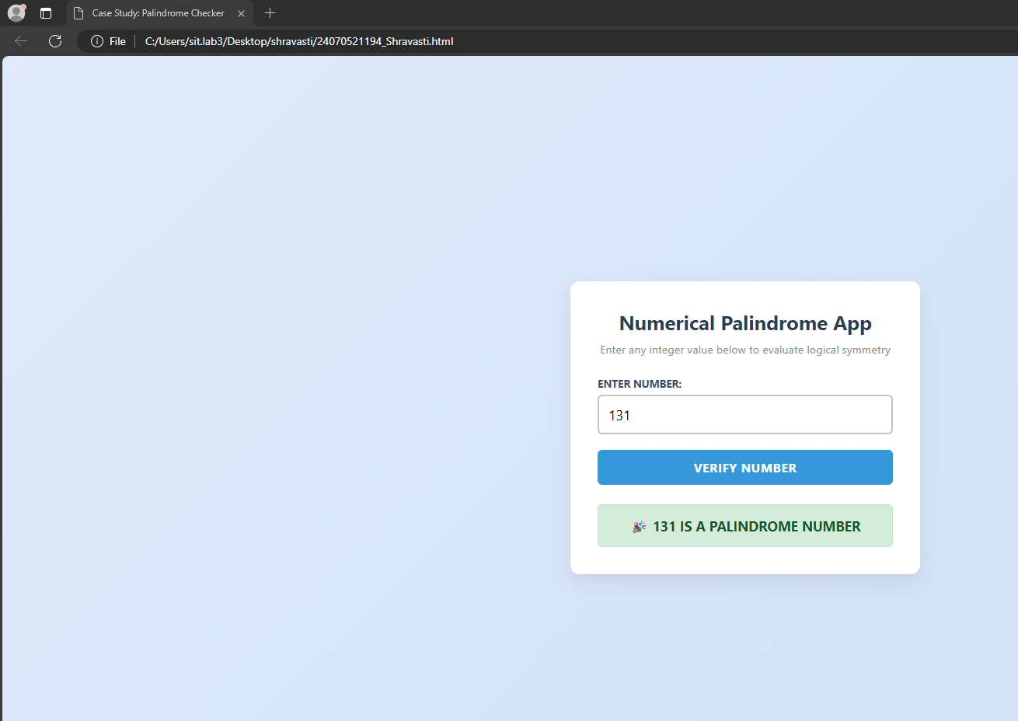
🏁 6. Conclusion
The implementation of the Palindrome Checker Case Study was concluded successfully. The single-page utility proves how basic client-side array transformations (split, reverse, join) can handle comparative programming arithmetic without complex mathematical division loops (like using mod % 10). The interface provides fast data rendering and structural layout shifts, meeting all core project requirements perfectly.

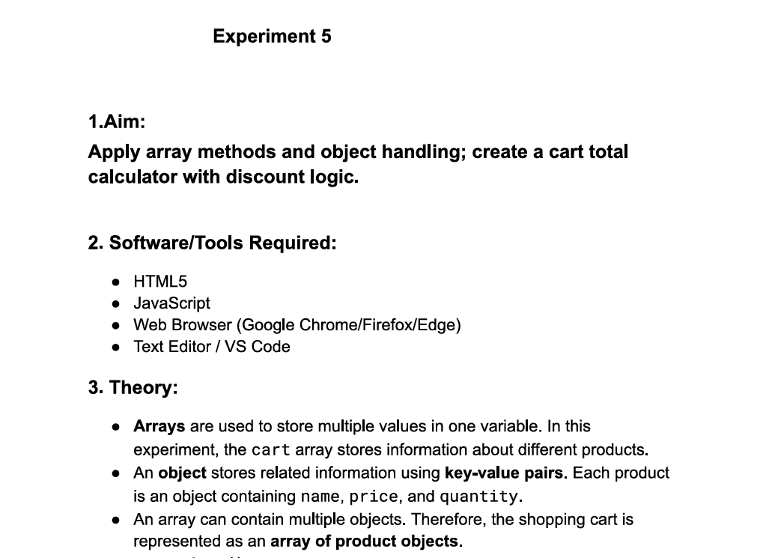
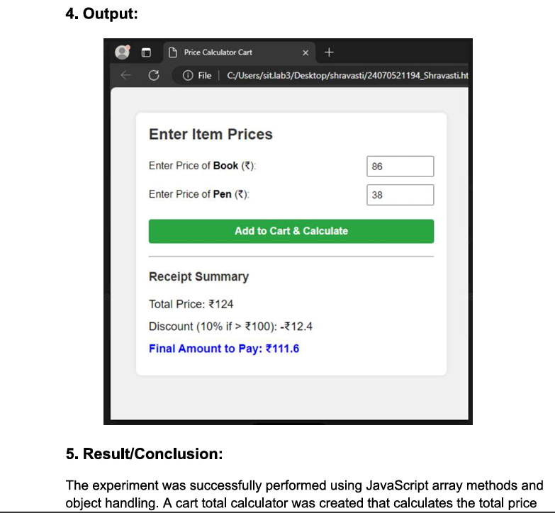

Case study 5

1. Aim
To create an easy-to-use web interface using HTML and JavaScript to study how arrays hold data, how basic tools add or remove data, and how loops extract it.
2. Theory (Simple Explanation)
An array is like a numbered grocery list. JavaScript has simple built-in rules to interact with it:
- To Add Data: push() adds an item to the bottom of the list. unshift() adds it to the top.
- To Remove Data: pop() drops the last item. shift() drops the very first item.
- To Cut/Copy: splice() cuts an item out from the middle of the list. slice() cleanly copies a section of the list without modifying it.
- Loops: forEach() steps through every single row one-by-one to read items. map() creates a brand-new modified list, and filter() creates a smaller copy holding only items that pass a specific criteria check.

Code
<!DOCTYPE html>
<html lang="en">
<head>
<meta charset="UTF-8">
<meta name="viewport" content="width=device-width, initial-scale=1.0">
<title>Easy Array Methods</title>
<style>
body {
font-family: Arial, sans-serif;
background-color: #f3f4f6;
padding: 30px;
text-align: center;
}
.container {
max-width: 600px;
margin: 0 auto;
background: white;
padding: 20px;
border-radius: 8px;
box-shadow: 0 4px 8px rgba(0,0,0,0.1);
}
input {
padding: 8px;
width: 60%;
margin-bottom: 15px;
font-size: 1rem;
}
.btn-section {
margin-bottom: 20px;
}
button {
padding: 8px 12px;
margin: 4px;
font-weight: bold;
cursor: pointer;
border-radius: 4px;
border: 1px solid #ccc;
}
.btn-add { background-color: #d1fae5; color: #065f46; }
.btn-remove { background-color: #fee2e2; color: #991b1b; }
.btn-loop { background-color: #dbeafe; color: #1e40af; }

.display-box {
background-color: #1e293b;
color: #38bdf8;
padding: 15px;
border-radius: 4px;
font-family: monospace;
font-size: 1.1rem;
min-height: 40px;
margin-top: 10px;
}
.console-box {
background-color: #f8fafc;
border: 1px solid #cbd5e1;
padding: 10px;
text-align: left;
font-family: monospace;
white-space: pre-line;
margin-top: 10px;
}
</style>
</head>
<body>

<div class="container">
<h2>Easy Array & Loop Workbench</h2>
<p>Type a word and click the buttons to manipulate the array list.</p>

<input type="text" id="userInput" placeholder="Type something... (e.g. Apple)">

<div class="btn-section">
<h4>1. Basics (Start & End)</h4>
<button class="btn-add" onclick="doPush()">Push (Add to End)</button>
<button class="btn-remove" onclick="doPop()">Pop (Remove Last)</button>
<button class="btn-add" onclick="doUnshift()">Unshift (Add to Start)</button>
<button class="btn-remove" onclick="doShift()">Shift (Remove First)</button>
</div>

<div class="btn-section">
<h4>2. Advanced (Cut out / Copy chunks)</h4>
<button onclick="doSplice()">Splice (Cut Index 1)</button>
<button onclick="doSlice()">Slice (Copy First 2 Items)</button>
</div>

<div class="btn-section">
<h4>3. Loops & Filters</h4>
<button class="btn-loop" onclick="doForEach()">forEach() Loop</button>
<button class="btn-loop" onclick="doMap()">map() To UpperCase</button>
<button class="btn-loop" onclick="doFilter()">filter() Words > 3 letters</button>
</div>

<h3>Current Array Status:</h3>
<div id="arrayDisplay" class="display-box"></div>

<h3>Output Terminal:</h3>
<div id="consoleDisplay" class="console-box">Click a button to view output text logic explanations.</div>
</div>

<script>
// Starting items in our array list
let myList = ["HTML", "CSS", "JS"];

// Run this function automatically when the page loads to show the starting array
window.onload = function() {
showArray();
};

// Helper function to print out the active array items on screen
function showArray() {
const display = document.getElementById("arrayDisplay");
if (myList.length === 0) {
display.innerText = "[ Empty List ]";
} else {
display.innerText = "[ " + myList.join(", ") + " ]";
}
}

function printLog(msg) {
document.getElementById("consoleDisplay").innerText = msg;
}

/* --- BASIC METHODS --- */

function doPush() {
let val = document.getElementById("userInput").value.trim();
if(!val) return alert("Type a word first!");
myList.push(val); // Adds to end
showArray();
printLog("push() executed: Added '" + val + "' to the END of the list.");
document.getElementById("userInput").value = "";
}

function doPop() {
if(myList.length === 0) return alert("List is already empty!");
let removed = myList.pop(); // Removes from end
showArray();
printLog("pop() executed: Removed '" + removed + "' from the END of the list.");
}

function doUnshift() {
let val = document.getElementById("userInput").value.trim();
if(!val) return alert("Type a word first!");
myList.unshift(val); // Adds to start
showArray();
printLog("unshift() executed: Added '" + val + "' to the START of the list.");
document.getElementById("userInput").value = "";
}

function doShift() {
if(myList.length === 0) return alert("List is already empty!");
let removed = myList.shift(); // Removes from start
showArray();
printLog("shift() executed: Removed '" + removed + "' from the START of the list.");
}

/* --- ADVANCED METHODS --- */

function doSplice() {
if(myList.length < 2) return alert("Add more items first!");
let removed = myList.splice(1, 1); // Cuts 1 item at index position 1
showArray();
printLog("splice(1, 1) executed: Permanently cut out item at index position: '" + removed + "'");
}

function doSlice() {
let copiedChunk = myList.slice(0, 2); // Copies items from index 0 up to 2 (does not change original list)
printLog("slice(0, 2) executed: Copied first 2 items without hurting the original list.\nCopied items output: [ " + copiedChunk.join(", ") + " ]");
}

/* --- LOOPS & TRANSFORMS --- */

function doForEach() {
let resultText = "forEach() loop visited every item:\n";
myList.forEach(function(item, index) {
resultText += "• Position " + index + " contains item: " + item + "\n";
});
printLog(resultText);
}

function doMap() {
// map() goes over each word and turns it to UPPERCASE in a new list
let upperList = myList.map(function(item) {
return item.toUpperCase();
});
printLog("map() created a NEW list changing everything to UPPERCASE:\n[ " + upperList.join(", ") + " ]");
}

function doFilter() {
// filter() checks words and saves them only if length is greater than 3 letters
let longWords = myList.filter(function(item) {
return item.length > 3;
});
printLog("filter() created a NEW list keeping only words > 3 characters:\n[ " + longWords.join(", ") + " ]");
}
</script>
</body>
</html>

Output :
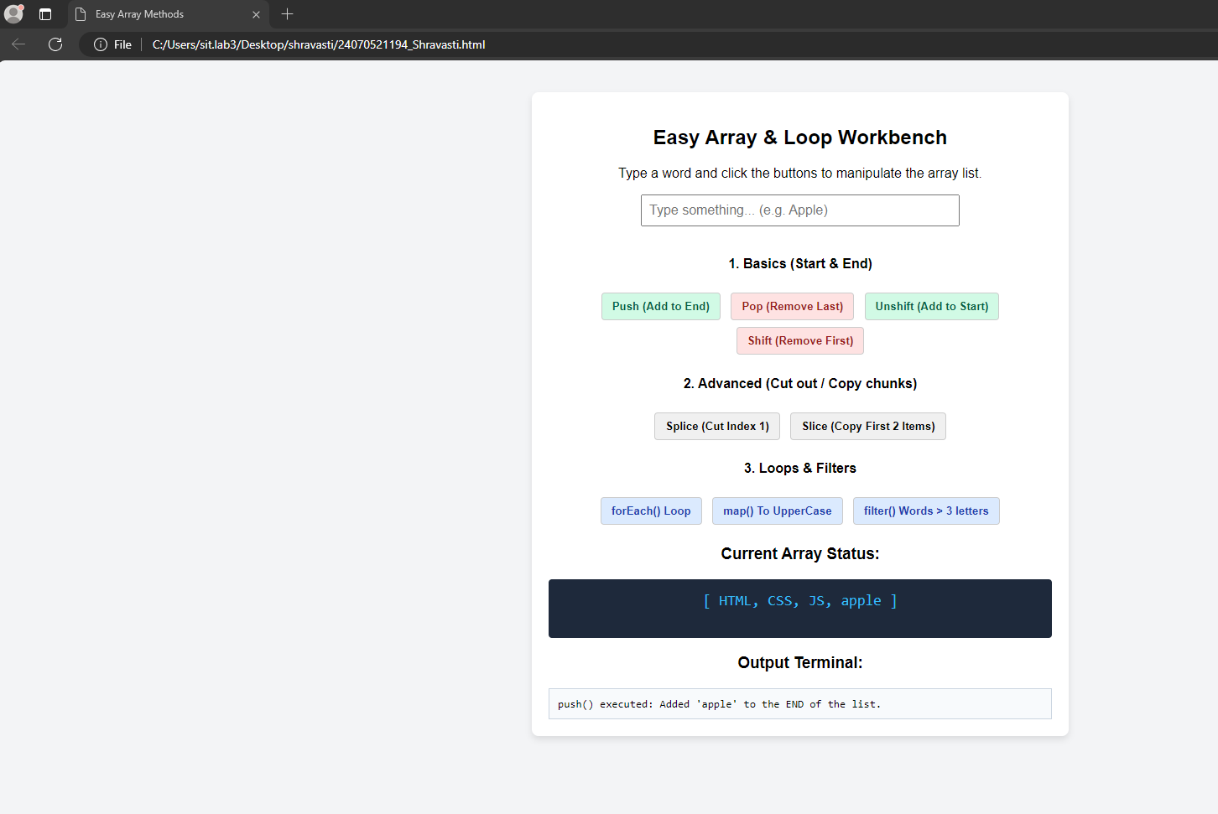

3. Conclusion
The simplified array testing laboratory assignment was completed successfully. By writing basic button actions, we successfully demonstrated how client-side arrays update their positions and lengths dynamically, and how loops read through collections easily.

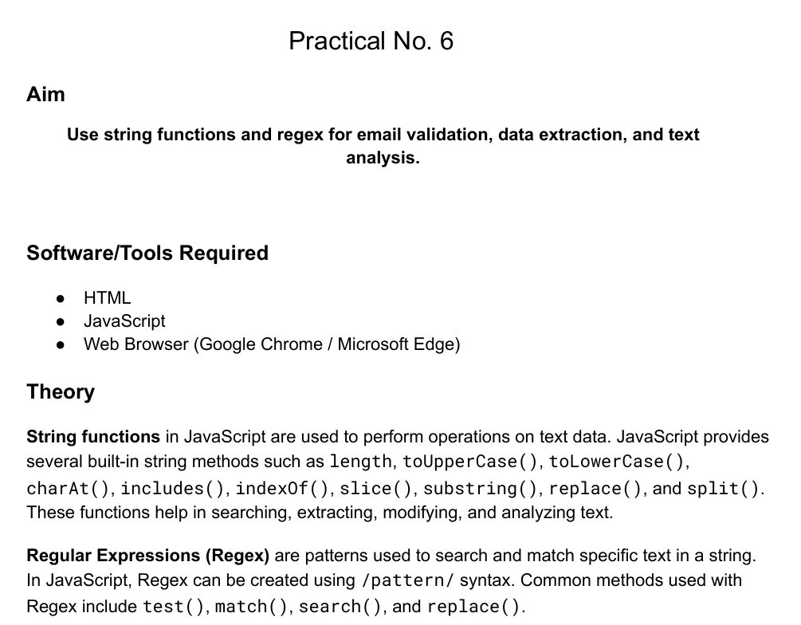
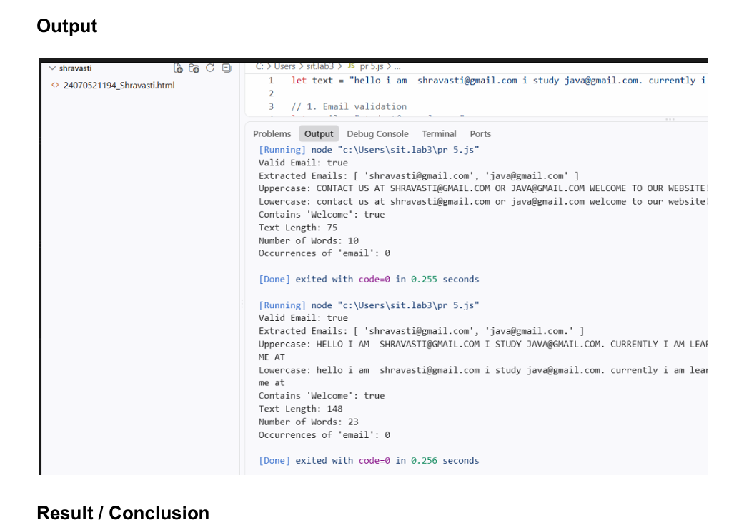
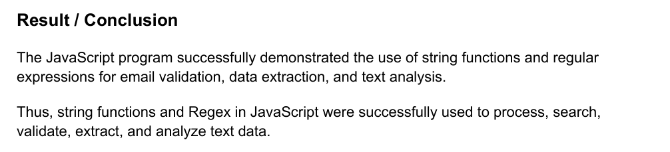

Case study 6
1. Case Study Title: To demonstrate JavaScript string operations using substring(), indexOf(), split(), replace(), string reversal, and vowel counting based on user input.

2. Case Study Program Code:
<!DOCTYPE html>
<html>
<head>
<title>String Operations</title>

<style>
body {
background-color: rgb(239, 171, 243);
font-family: Arial, sans-serif;
padding: 20px;
}

input {
padding: 8px;
margin: 5px 0 15px 0;
width: 350px;
display: block;
}

textarea {
padding: 10px;
margin: 5px 0 15px 0;
width: 500px;
height: 80px;
display: block;
}

button {
padding: 10px 20px;
margin: 10px 0;
cursor: pointer;
}

#output {
margin-top: 20px;
font-size: 18px;
line-height: 1.6;
}
</style>
</head>

<body>

<h2>Sonal's JavaScript String Operations</h2>

<label for="str">Enter String:</label>
<textarea id="str" placeholder="Enter your string or paragraph"></textarea>

<label for="start">Substring Start Index:</label>
<input type="number" id="start" placeholder="Enter start index (e.g., 0)">

<label for="end">Substring End Index:</label>
<input type="number" id="end" placeholder="Enter end index">

<label for="search">IndexOf - Enter text to search:</label>
<input type="text" id="search" placeholder="Enter character or word">

<label for="separator">Split - Enter separator:</label>
<input type="text" id="separator" placeholder="Type a character or 'space'">

<label for="oldText">Replace - Text to replace:</label>
<input type="text" id="oldText" placeholder="Enter text to replace">

<label for="newText">Replace - New text:</label>
<input type="text" id="newText" placeholder="Enter new text">

<button onclick="performOperations()">Perform Operations</button>

<div id="output"></div>

<script>
function performOperations() {
let str = document.getElementById("str").value;

if (!str) {
document.getElementById("output").innerHTML = "<strong>Please enter a valid string first!</strong>";
return;
}

let start = Number(document.getElementById("start").value);
let end = Number(document.getElementById("end").value);

let search = document.getElementById("search").value;
let separator = document.getElementById("separator").value;

let oldText = document.getElementById("oldText").value;
let newText = document.getElementById("newText").value;

let output = "";

// Substring (Handles cases where end index isn't specified)
let subResult = (end > 0) ? str.substring(start, end) : str.substring(start);
output += "<strong>Substring:</strong> " + subResult + "<br>";

// IndexOf
if (search) {
output += "<strong>Index of '" + search + "':</strong> " + str.indexOf(search) + "<br>";
}

// Split
if (separator) {
let sepChar = (separator === "space") ? " " : separator;
output += "<strong>Split:</strong> [" + str.split(sepChar).join(", ") + "]<br>";
}

// Replace (Replaces all instances safely)
if (oldText) {
output += "<strong>Replace:</strong> " + str.replaceAll(oldText, newText) + "<br>";
}

// Reverse
let reverse = str.split("").reverse().join("");
output += "<strong>Reversed String:</strong> " + reverse + "<br>";

// Count Vowels (Using regex for cleaner execution)
let vowelMatch = str.match(/[aeiou]/gi);
let count = vowelMatch ? vowelMatch.length : 0;

output += "<strong>Number of Vowels:</strong> " + count;

document.getElementById("output").innerHTML = output;
}
</script>
</body>
</html>

3. Output:
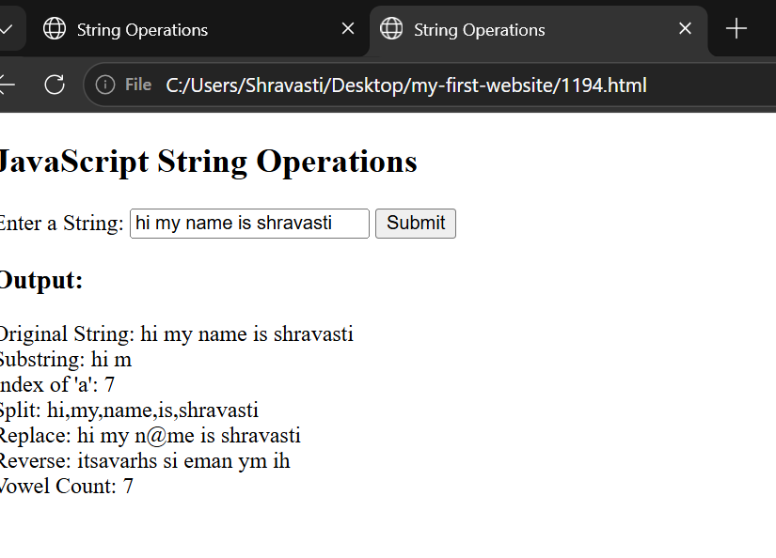
4. Result/Conclusion: Thus, various JavaScript string operations were successfully performed, including substring extraction, text searching, splitting, replacing, reversing, and vowel counting, and the results were displayed dynamically on the webpage.

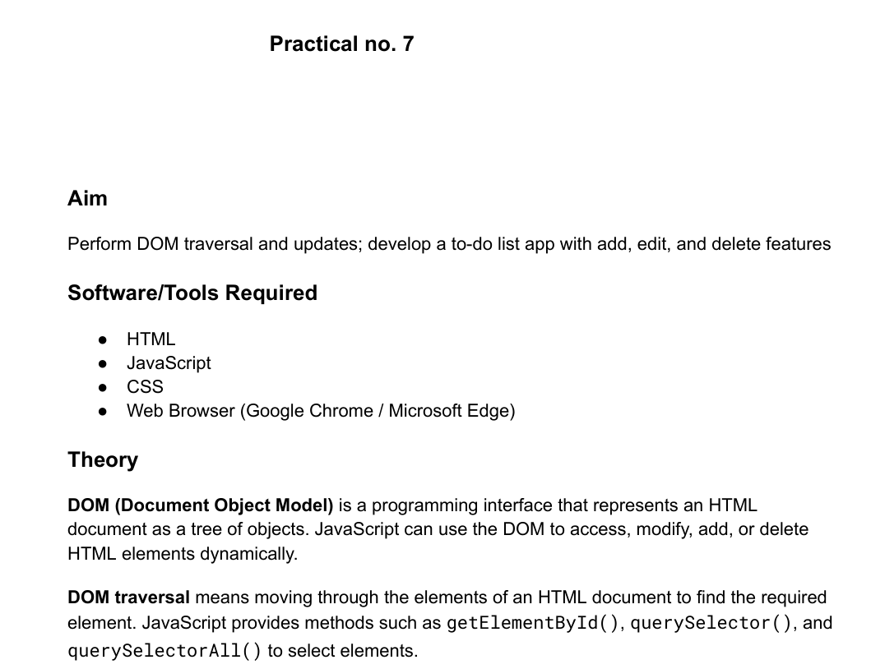
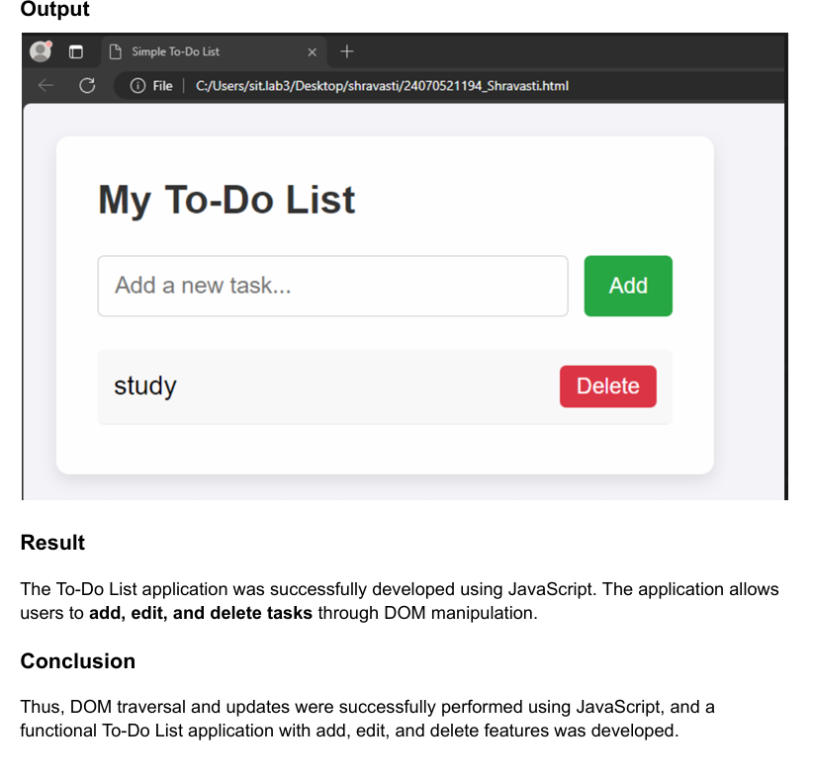

Case Study No.: 7

1. Case Study Title: To demonstrate events handling in javascript, a) access and manipulate from elements using javascript. b) validate user input (eg. email,empty,fields) c) use various form events (submit,change,focus).

2. Case Study Program Code:
//shravasti shende 24070521194

<!DOCTYPE html>
<html>
<head>
<title>Sonal's - Event Handling</title>

<style>
body {
font-family: Arial, sans-serif;
background-color: #e8f0fe;
padding: 40px;
}

.form-box {
width: 450px;
margin: auto;
background-color: white;
padding: 25px;
border-radius: 10px;
box-shadow: 0 4px 12px gray;
}

h2 {
text-align: center;
}

label {
display: block;
margin-top: 15px;
font-weight: bold;
}

input, select {
width: 100%;
padding: 10px;
margin-top: 5px;
box-sizing: border-box;
}

input:focus, select:focus {
border: 2px solid blue;
outline: none;
}

.error {
color: red;
font-size: 13px;
}

button {
width: 100%;
margin-top: 20px;
padding: 10px;
background-color: #2563eb;
color: white;
border: none;
cursor: pointer;
}

#message {
text-align: center;
font-weight: bold;
margin-top: 15px;
}
</style>
</head>

<body>

<div class="form-box">

<h2>Sonal's student Registration Form</h2>

<form id="studentForm">

<label>Name:</label>
<input type="text" id="name">
<div id="nameError" class="error"></div>

<label>Email:</label>
<input type="text" id="email">
<div id="emailError" class="error"></div>

<label>Course:</label>
<select id="course">
<option value="">Select Course</option>
<option value="CSE">Computer Science</option>
<option value="IT">Information Technology</option>
<option value="ECE">Electronics</option>
</select>
<div id="courseError" class="error"></div>

<button type="submit">Submit</button>

</form>

<p id="message"></p>

</div>

<script>

// Access form elements
let form = document.getElementById("studentForm");
let name = document.getElementById("name");
let email = document.getElementById("email");
let course = document.getElementById("course");

// Focus event
name.addEventListener("focus", function() {
name.style.backgroundColor = "#eef4ff";
});

email.addEventListener("focus", function() {
email.style.backgroundColor = "#eef4ff";
});

// Change event
course.addEventListener("change", function() {
document.getElementById("courseError").innerText =
"Selected Course: " + course.value;
});

// Submit event
form.addEventListener("submit", function(event) {

event.preventDefault();

let valid = true;

// Name validation
if (name.value.trim() === "") {
document.getElementById("nameError").innerText =
"Name cannot be empty";
valid = false;
} else {
document.getElementById("nameError").innerText = "";
}

// Email validation
let emailPattern = /^[^\s@]+@[^\s@]+\.[^\s@]+$/;

if (email.value.trim() === "") {
document.getElementById("emailError").innerText =
"Email cannot be empty";
valid = false;
}
else if (!emailPattern.test(email.value)) {
document.getElementById("emailError").innerText =
"Enter a valid email";
valid = false;
}
else {
document.getElementById("emailError").innerText = "";
}

// Course validation
if (course.value === "") {
document.getElementById("courseError").innerText =
"Please select a course";
valid = false;
}

// Final result
if (valid) {
document.getElementById("message").innerText =
"Registration submitted successfully!";
document.getElementById("message").style.color = "green";
}
else {
document.getElementById("message").innerText =
"Please correct the errors.";
document.getElementById("message").style.color = "red";
}

});

</script>

</body>
</html>

Output
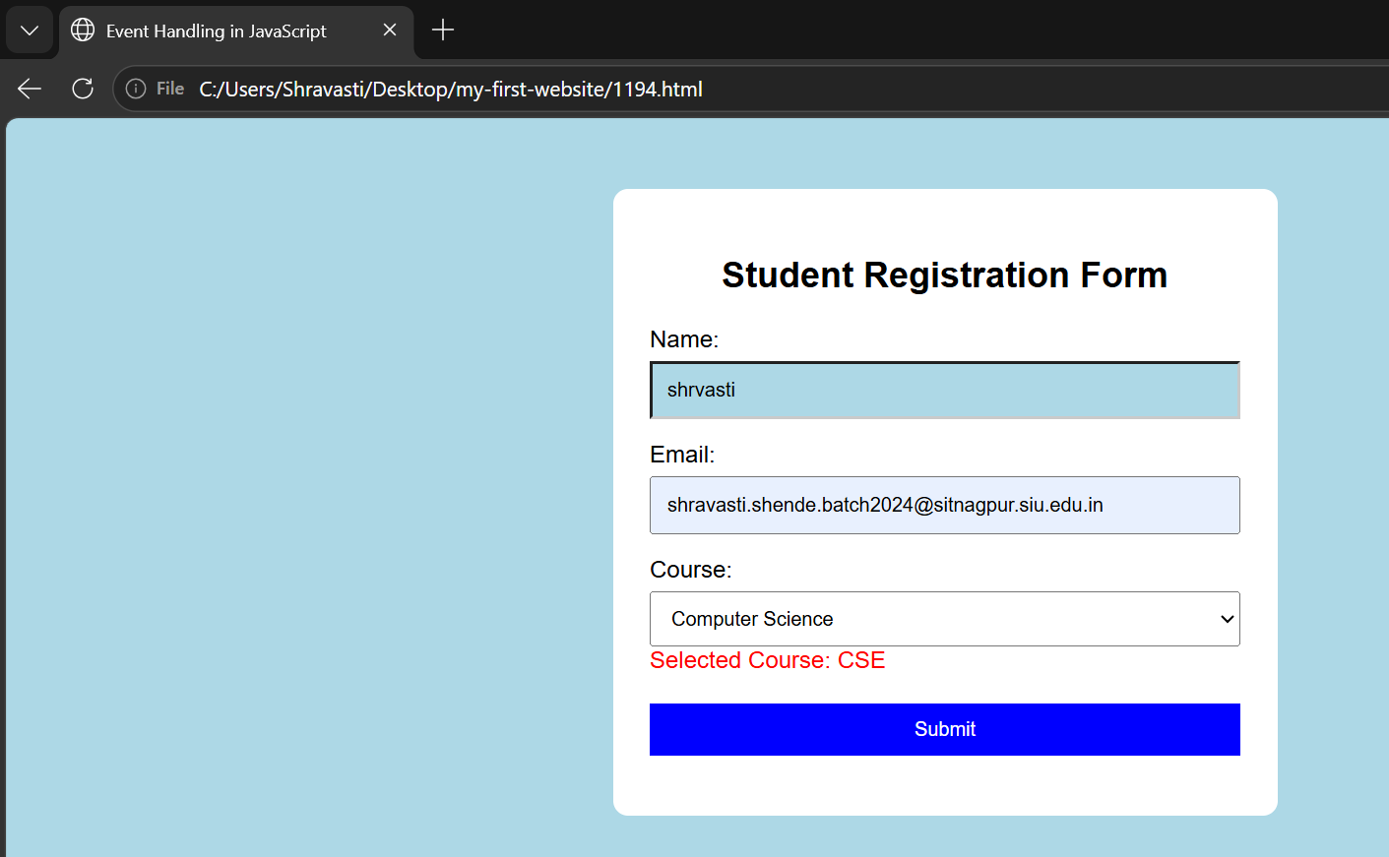

4. Result/Conclusion: This experiment demonstrated the core mechanics of JavaScript arrays and iterative processing. Highlighting how different methods handle data manipulation, transformation, and evaluation. Modifying arrays using push(), pop(), shift(), unshift(), splice(), and slice() established a practical understanding of element positioning and the distinction between mutating original data versus returning new copies. Furthermore, utilizing functional array methods like forEach(), map(), filter(), and reduce() illustrated a clean, declarative alternative to traditional looping for transforming and aggregating data. Finally, calculating the maximum and minimum values of a number array using Math.max()/Math.min() with the spread operator, reduce(), and classic for loops demonstrated how algorithmic logic and modern language features can solve fundamental computational problems efficiently.

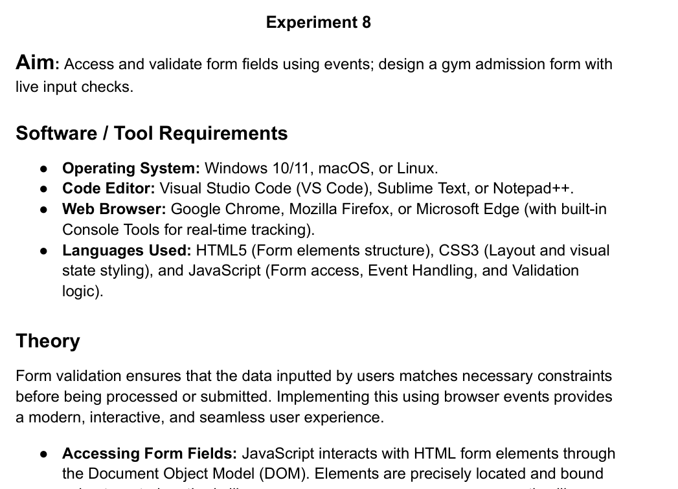
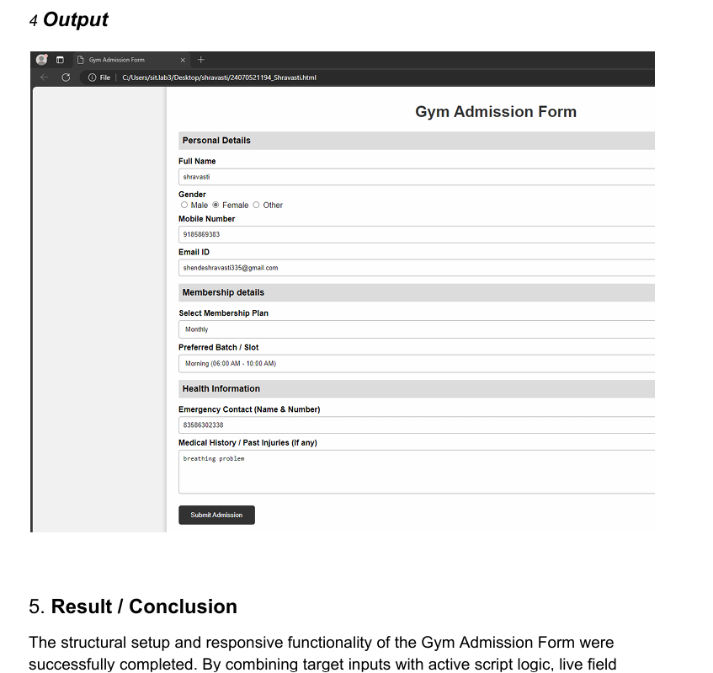

Casr study 8

- Case Study Title:
Online Job Application Form, A company wants to create an online job application form that checks the entered information immediately and prevents submission when the details are invalid.

2. Case Study Program Code:
//Sharvasti shende 24070521194

<!DOCTYPE html>
<html lang="en">
<head>
<meta charset="UTF-8">
<title>Sonal's Online Job Application Form</title>
<style>
body {
background-color: #dce7ff;
font-family: Arial, sans-serif;
display: flex;
justify-content: center;
padding: 20px 0;
}

.form-card {
background-color: #ffffff;
width: 550px;
padding: 25px 30px;
border-radius: 12px;
box-shadow: 0 4px 15px rgba(0,0,0,0.1);
}

h2 {
text-align: center;
color: #2b2b80;
margin-top: 0;
}

.section-title {
color: #4343ff;
font-size: 18px;
font-weight: bold;
margin-top: 20px;
margin-bottom: 10px;
border-bottom: 1px solid #ddd;
padding-bottom: 5px;
}

.form-group {
margin-bottom: 15px;
}

label {
display: block;
font-weight: bold;
font-size: 14px;
margin-bottom: 5px;
}

input[type="text"],
input[type="date"],
input[type="number"],
select,
textarea {
width: 100%;
padding: 10px;
border: 1px solid #ccc;
border-radius: 6px;
box-sizing: border-box;
font-size: 14px;
}

textarea {
height: 70px;
resize: vertical;
}

.radio-group {
display: flex;
gap: 15px;
align-items: center;
font-size: 14px;
}

.radio-group input {
margin-right: 5px;
}

.msg {
font-size: 12px;
margin-top: 4px;
font-weight: bold;
}

.msg.valid {
color: #1a8a2a;
}

.msg.invalid {
color: #ff0000;
}

.submit-btn {
width: 100%;
padding: 12px;
background-color: #4343ff;
color: white;
border: none;
border-radius: 6px;
font-size: 16px;
font-weight: bold;
cursor: pointer;
margin-top: 20px;
}

.submit-btn:hover {
background-color: #2b2b80;
}

#form-status {
text-align: center;
font-weight: bold;
margin-top: 15px;
font-size: 14px;
}
</style>
</head>
<body>

<div class="form-card">
<h2>💼 Sonal Online Job Application Form</h2>

<form id="jobForm">
<!-- Personal Information -->
<div class="section-title">Personal Information</div>

<div class="form-group">
<label>Full Name:</label>
<input type="text" id="fullName" placeholder="Enter full name">
<div id="fullNameMsg" class="msg"></div>
</div>

<div class="form-group">
<label>Date of Birth:</label>
<input type="date" id="dob">
<div id="dobMsg" class="msg"></div>
</div>

<div class="form-group">
<label>Gender:</label>
<div class="radio-group">
<label><input type="radio" name="gender" value="Male"> Male</label>
<label><input type="radio" name="gender" value="Female"> Female</label>
<label><input type="radio" name="gender" value="Other"> Other</label>
</div>
<div id="genderMsg" class="msg"></div>
</div>

<div class="form-group">
<label>Email Address:</label>
<input type="text" id="email" placeholder="Enter email address">
<div id="emailMsg" class="msg"></div>
</div>

<div class="form-group">
<label>Mobile Number:</label>
<input type="text" id="mobile" placeholder="Enter mobile number">
<div id="mobileMsg" class="msg"></div>
</div>

<div class="form-group">
<label>Address:</label>
<textarea id="address" placeholder="Enter address"></textarea>
<div id="addressMsg" class="msg"></div>
</div>

<div class="form-group">
<label>City:</label>
<input type="text" id="city" placeholder="Enter city">
<div id="cityMsg" class="msg"></div>
</div>

<div class="form-group">
<label>State:</label>
<input type="text" id="state" placeholder="Enter state">
<div id="stateMsg" class="msg"></div>
</div>

<div class="form-group">
<label>PIN Code:</label>
<input type="text" id="pincode" placeholder="Enter 6-digit PIN code">
<div id="pincodeMsg" class="msg"></div>
</div>

<div class="form-group">
<label>Educational Qualification:</label>
<select id="qualification">
<option value="">Select Qualification</option>
<option value="B.Tech">B.Tech</option>
<option value="B.Sc">B.Sc</option>
<option value="M.Tech">M.Tech</option>
<option value="Other">Other</option>
</select>
<div id="qualificationMsg" class="msg"></div>
</div>

<div class="form-group">
<label>Percentage:</label>
<input type="number" id="percentage" placeholder="Enter percentage">
<div id="percentageMsg" class="msg"></div>
</div>

<div class="form-group">
<label>Passing Year:</label>
<input type="number" id="passingYear" placeholder="Enter passing year">
<div id="passingYearMsg" class="msg"></div>
</div>

<!-- Professional Information -->
<div class="section-title">Professional Information</div>

<div class="form-group">
<label>Applying for Job Position:</label>
<input type="text" id="jobPosition" placeholder="Enter job position">
<div id="jobPositionMsg" class="msg"></div>
</div>

<div class="form-group">
<label>Total Work Experience (Years):</label>
<input type="number" id="experience" placeholder="Enter work experience">
<div id="experienceMsg" class="msg"></div>
</div>

<div class="form-group">
<label>Current / Previous Organization:</label>
<input type="text" id="organization" placeholder="Enter organization name">
<div id="organizationMsg" class="msg"></div>
</div>

<div class="form-group">
<label>Current Designation:</label>
<input type="text" id="designation" placeholder="Enter designation">
<div id="designationMsg" class="msg"></div>
</div>

<div class="form-group">
<label>Expected Salary:</label>
<input type="number" id="salary" placeholder="Enter expected salary">
<div id="salaryMsg" class="msg"></div>
</div>

<div class="form-group">
<label>Technical Skills:</label>
<textarea id="skills" placeholder="Enter technical skills"></textarea>
<div id="skillsMsg" class="msg"></div>
</div>

<button type="button" class="submit-btn" onclick="validateForm()">Submit Application</button>

<div id="form-status"></div>
</form>
</div>

<script>
// Helper function to update feedback messages
function setMsg(elementId, text, isValid) {
let msgElement = document.getElementById(elementId);
msgElement.innerHTML = (isValid ? "✓ " : "") + text;
msgElement.className = "msg " + (isValid ? "valid" : "invalid");
}

function validateFullName() {
let val = document.getElementById("fullName").value.trim();
if (val.length >= 2) {
setMsg("fullNameMsg", "Valid name", true);
return true;
} else {
setMsg("fullNameMsg", "Invalid name", false);
return false;
}
}

function validateDOB() {
let val = document.getElementById("dob").value;
if (val !== "") {
setMsg("dobMsg", "Date of birth selected", true);
return true;
} else {
setMsg("dobMsg", "Please select date of birth", false);
return false;
}
}

function validateGender() {
let selected = document.querySelector('input[name="gender"]:checked');
if (selected) {
setMsg("genderMsg", "Gender selected", true);
return true;
} else {
setMsg("genderMsg", "Please select gender", false);
return false;
}
}

function validateEmail() {
let val = document.getElementById("email").value.trim();
let emailPattern = /^[^\s@]+@[^\s@]+\.[^\s@]+$/;
if (emailPattern.test(val)) {
setMsg("emailMsg", "Valid email address", true);
return true;
} else {
setMsg("emailMsg", "Invalid email address", false);
return false;
}
}

function validateMobile() {
let val = document.getElementById("mobile").value.trim();
if (/^\d{10}$/.test(val)) {
setMsg("mobileMsg", "Valid mobile number", true);
return true;
} else {
setMsg("mobileMsg", "Invalid mobile number - enter 10 digits", false);
return false;
}
}

function validateAddress() {
let val = document.getElementById("address").value.trim();
if (val.length > 5) {
setMsg("addressMsg", "Valid address", true);
return true;
} else {
setMsg("addressMsg", "Invalid address", false);
return false;
}
}

function validateCity() {
let val = document.getElementById("city").value.trim();
if (val.length >= 2) {
setMsg("cityMsg", "Valid city", true);
return true;
} else {
setMsg("cityMsg", "Invalid city", false);
return false;
}
}

function validateState() {
let val = document.getElementById("state").value.trim();
if (val.length >= 2) {
setMsg("stateMsg", "Valid state", true);
return true;
} else {
setMsg("stateMsg", "Invalid state", false);
return false;
}
}

function validatePincode() {
let val = document.getElementById("pincode").value.trim();
if (/^\d{6}$/.test(val)) {
setMsg("pincodeMsg", "Valid PIN code", true);
return true;
} else {
setMsg("pincodeMsg", "Invalid PIN - enter 6 digits", false);
return false;
}
}

function validateQualification() {
let val = document.getElementById("qualification").value;
if (val !== "") {
setMsg("qualificationMsg", "Qualification selected", true);
return true;
} else {
setMsg("qualificationMsg", "Please select qualification", false);
return false;
}
}

function validatePercentage() {
let val = Number(document.getElementById("percentage").value);
if (val > 0 && val <= 100) {
setMsg("percentageMsg", "Valid percentage", true);
return true;
} else {
setMsg("percentageMsg", "Invalid percentage", false);
return false;
}
}

function validatePassingYear() {
let val = Number(document.getElementById("passingYear").value);
let currentYear = new Date().getFullYear();
if (val >= 1970 && val <= currentYear) {
setMsg("passingYearMsg", "Valid passing year", true);
return true;
} else {
setMsg("passingYearMsg", "Invalid passing year", false);
return false;
}
}

function validateJobPosition() {
let val = document.getElementById("jobPosition").value.trim();
if (val.length >= 2) {
setMsg("jobPositionMsg", "Valid job position", true);
return true;
} else {
setMsg("jobPositionMsg", "Invalid job position", false);
return false;
}
}

function validateExperience() {
let val = document.getElementById("experience").value;
if (val !== "" && Number(val) >= 0) {
setMsg("experienceMsg", "Valid experience", true);
return true;
} else {
setMsg("experienceMsg", "Experience cannot be negative", false);
return false;
}
}

function validateOrganization() {
let val = document.getElementById("organization").value.trim();
if (val.length >= 2) {
setMsg("organizationMsg", "Valid organization", true);
return true;
} else {
setMsg("organizationMsg", "Invalid organization", false);
return false;
}
}

function validateDesignation() {
let val = document.getElementById("designation").value.trim();
if (val.length >= 2) {
setMsg("designationMsg", "Valid designation", true);
return true;
} else {
setMsg("designationMsg", "Invalid designation", false);
return false;
}
}

function validateSalary() {
let val = Number(document.getElementById("salary").value);
if (val > 0) {
setMsg("salaryMsg", "Valid expected salary", true);
return true;
} else {
setMsg("salaryMsg", "Invalid expected salary", false);
return false;
}
}

function validateSkills() {
let val = document.getElementById("skills").value.trim();
if (val.length >= 2) {
setMsg("skillsMsg", "Skills entered", true);
return true;
} else {
setMsg("skillsMsg", "Please enter skills", false);
return false;
}
}

// Attach real-time validation event listeners
document.getElementById("fullName").addEventListener("input", validateFullName);
document.getElementById("dob").addEventListener("change", validateDOB);
document.querySelectorAll('input[name="gender"]').forEach(radio => radio.addEventListener("change", validateGender));
document.getElementById("email").addEventListener("input", validateEmail);
document.getElementById("mobile").addEventListener("input", validateMobile);
document.getElementById("address").addEventListener("input", validateAddress);
document.getElementById("city").addEventListener("input", validateCity);
document.getElementById("state").addEventListener("input", validateState);
document.getElementById("pincode").addEventListener("input", validatePincode);
document.getElementById("qualification").addEventListener("change", validateQualification);
document.getElementById("percentage").addEventListener("input", validatePercentage);
document.getElementById("passingYear").addEventListener("input", validatePassingYear);
document.getElementById("jobPosition").addEventListener("input", validateJobPosition);
document.getElementById("experience").addEventListener("input", validateExperience);
document.getElementById("organization").addEventListener("input", validateOrganization);
document.getElementById("designation").addEventListener("input", validateDesignation);
document.getElementById("salary").addEventListener("input", validateSalary);
document.getElementById("skills").addEventListener("input", validateSkills);

// Global form submission check
function validateForm() {
let isAllValid =
validateFullName() &
validateDOB() &
validateGender() &
validateEmail() &
validateMobile() &
validateAddress() &
validateCity() &
validateState() &
validatePincode() &
validateQualification() &
validatePercentage() &
validatePassingYear() &
validateJobPosition() &
validateExperience() &
validateOrganization() &
validateDesignation() &
validateSalary() &
validateSkills();

let statusDiv = document.getElementById("form-status");

if (isAllValid) {
statusDiv.style.color = "#1a8a2a";
statusDiv.innerHTML = "✓ Application submitted successfully!";
} else {
statusDiv.style.color = "#ff0000";
statusDiv.innerHTML = "✖ Please correct the invalid details before submitting.";
}
}
</script>

</body>
</html>

3. Output:
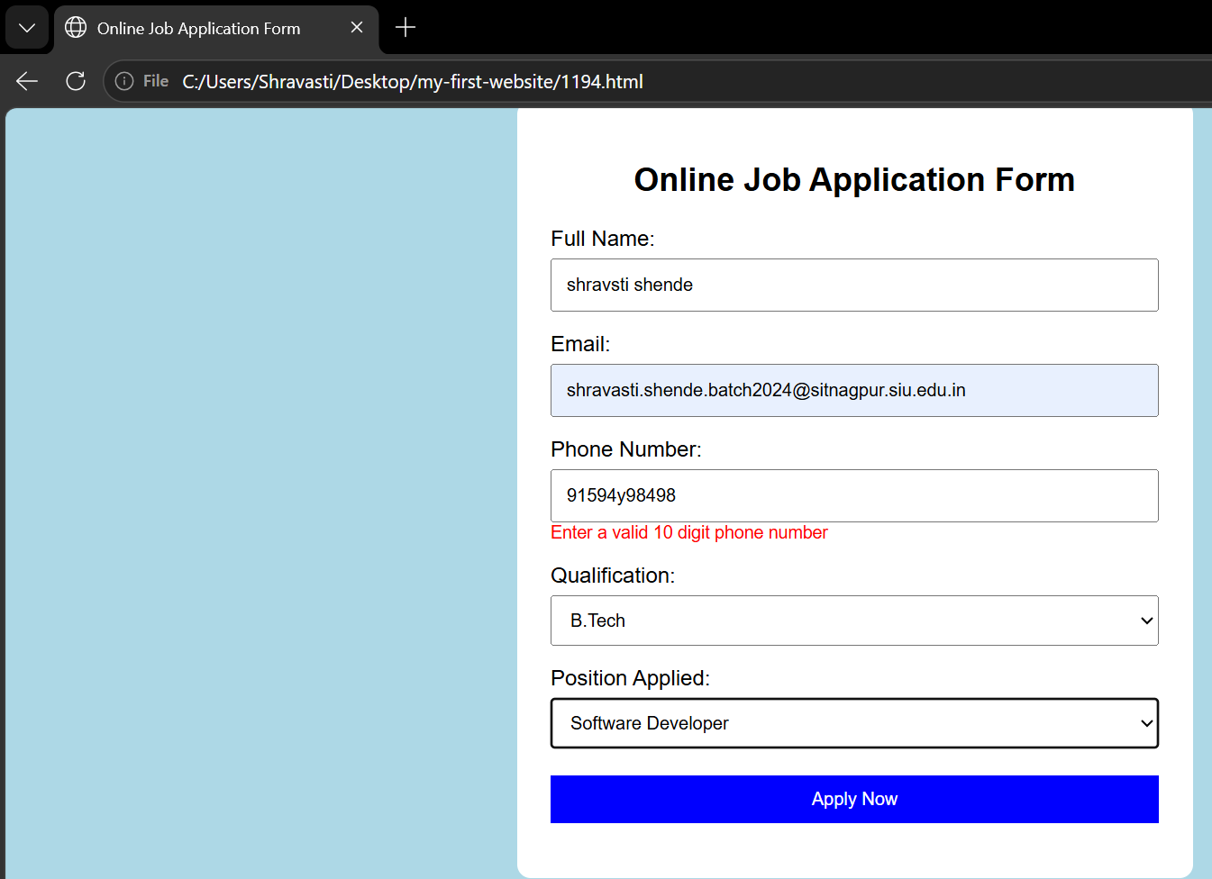

Result/Conclusion: Thus, an online job application form was successfully created with live validation to check user details and prevent invalid form submission.

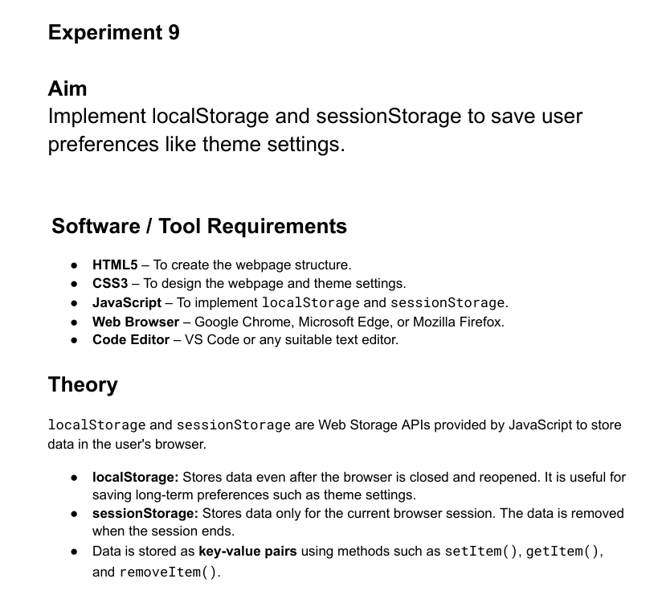
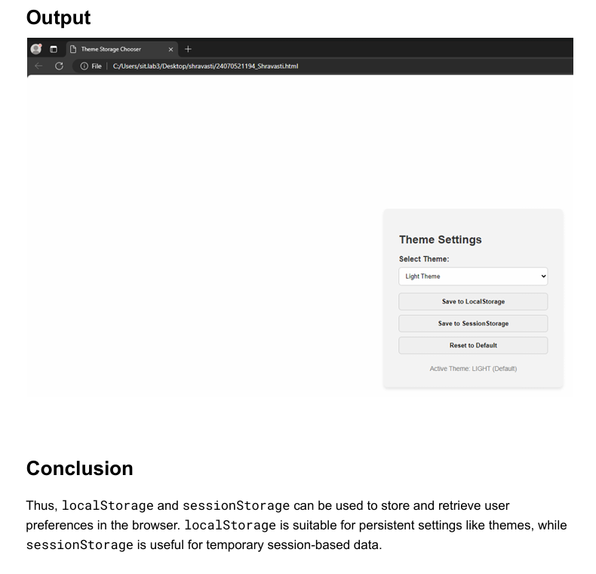

Case study 9

1. Case Study Title: Common Case Study Scenario for Practical 1-8
Develop a Student Task Management Web Application and apply Dark Theme and Light Theme functionality across all practicals 1-8.
The application should allow users to perform the activities covered in Practical 1-8, such as creating and managing tasks, updating content using DOM operations, handling user interactions, validating inputs, and dynamically modifying webpage elements.
• A Theme Toggle Button should be included in every practical application, allowing users to switch between Light Mode and Dark Mode. The selected theme should be saved using LocalStorage, so the user's preference remains available even after closing and reopening the browser.

2. Case Study Program Code:

<!DOCTYPE html>
<!—shravasti 1194 -->
<html lang="en">
<head>
<meta charset="UTF-8">
<meta name="viewport" content="width=device-width, initial-scale=1.0">
<title>Gym Admission Form</title>
<style>
/* CSS Theme Variables */
:root {
--bg-color: #f4f4f9;
--text-color: #333333;
--card-bg: #ffffff;
--border-color: #cccccc;
--input-bg: #ffffff;
--label-color: #555555;
--box-shadow: 0 4px 10px rgba(0, 0, 0, 0.1);
}

[data-theme="dark"] {
--bg-color: #121212;
--text-color: #f0f0f0;
--card-bg: #1e1e1e;
--border-color: #444444;
--input-bg: #2d2d2d;
--label-color: #bbbbbb;
--box-shadow: 0 4px 10px rgba(0, 0, 0, 0.5);
}

[data-theme="light"] {
--bg-color: #f4f4f9;
--text-color: #333333;
--card-bg: #ffffff;
--border-color: #cccccc;
--input-bg: #ffffff;
--label-color: #555555;
--box-shadow: 0 4px 10px rgba(0, 0, 0, 0.1);
}

body {
font-family: Arial, sans-serif;
background-color: var(--bg-color);
color: var(--text-color);
display: flex;
flex-direction: column;
justify-content: center;
align-items: center;
min-height: 100vh;
margin: 0;
padding: 20px 0;
box-sizing: border-box;
transition: background-color 0.3s, color 0.3s;
}

.theme-selector {
width: 100%;
max-width: 400px;
margin-bottom: 15px;
}

.form-container {
background: var(--card-bg);
padding: 25px 30px;
border-radius: 8px;
box-shadow: var(--box-shadow);
width: 100%;
max-width: 400px;
border: 1px solid var(--border-color);
box-sizing: border-box;
transition: background-color 0.3s, border-color 0.3s;
}

h2 {
text-align: center;
color: var(--text-color);
margin-bottom: 20px;
}

.form-group {
margin-bottom: 15px;
}

label {
display: block;
font-weight: bold;
margin-bottom: 5px;
color: var(--label-color);
}

input, select {
width: 100%;
padding: 10px;
border: 1px solid var(--border-color);
border-radius: 4px;
box-sizing: border-box;
font-size: 14px;
background-color: var(--input-bg);
color: var(--text-color);
}

input:focus, select:focus {
outline: none;
border-color: #007bff;
}

.error {
color: #dc3545;
font-size: 12px;
margin-top: 5px;
display: block;
min-height: 15px;
}

.valid {
border-color: #28a745 !important;
}

.invalid {
border-color: #dc3545 !important;
}

button {
width: 100%;
padding: 12px;
background-color: #007bff;
color: white;
border: none;
border-radius: 4px;
font-size: 16px;
font-weight: bold;
cursor: pointer;
}

button:hover {
background-color: #0056b3;
}

.success-msg {
color: #28a745;
text-align: center;
font-weight: bold;
margin-top: 15px;
}
</style>
</head>
<body>

<!-- Theme Selector Control -->
<div class="theme-selector">
<label for="themeSelect"><strong>Theme: </strong></label>
<select id="themeSelect" onchange="applyTheme(this.value)">
<option value="default" selected>System Default</option>
<option value="light">Light</option>
<option value="dark">Dark</option>
</select>
</div>

<div class="form-container">
<h2>Gym Admission Form</h2>
<form id="gymForm" novalidate>

<!-- Full Name -->
<div class="form-group">
<label for="fullName">Full Name</label>
<input type="text" id="fullName" placeholder="Enter your full name">
<span class="error" id="nameError"></span>
</div>

<!-- Email Address -->
<div class="form-group">
<label for="email">Email Address</label>
<input type="email" id="email" placeholder="abc@xyz.com">
<span class="error" id="emailError"></span>
</div>

<!-- Mobile Number -->
<div class="form-group">
<label for="mobile">Mobile Number</label>
<input type="tel" id="mobile" placeholder="10-digit mobile number">
<span class="error" id="mobileError"></span>
</div>

<!-- Age -->
<div class="form-group">
<label for="age">Age (18 - 50)</label>
<input type="number" id="age" placeholder="Enter your age">
<span class="error" id="ageError"></span>
</div>

<!-- Membership Plan -->
<div class="form-group">
<label for="plan">Membership Plan</label>
<select id="plan">
<option value="">-- Select a Plan --</option>
<option value="quarterly">Quarterly</option>
<option value="half-yearly">Half Yearly</option>
<option value="annually">Annually</option>
</select>
<span class="error" id="planError"></span>
</div>

<button type="submit">Submit Admission</button>
<div id="successMsg" class="success-msg"></div>
</form>
</div>

<script>
// Theme Switcher Logic
function applyTheme(theme) {
const root = document.documentElement;
if (theme === "default") {
const prefersDark = window.matchMedia("(prefers-color-scheme: dark)").matches;
root.setAttribute("data-theme", prefersDark ? "dark" : "light");
} else {
root.setAttribute("data-theme", theme);
}
}

// Apply default theme on page load
applyTheme("default");

// Get element references
const fullName = document.getElementById('fullName');
const email = document.getElementById('email');
const mobile = document.getElementById('mobile');
const age = document.getElementById('age');
const plan = document.getElementById('plan');
const gymForm = document.getElementById('gymForm');

// Helper function to update input styling and error message
function setValidationState(input, errorElement, isValid, errorMessage) {
if (isValid) {
input.classList.remove('invalid');
input.classList.add('valid');
errorElement.textContent = '';
return true;
} else {
input.classList.remove('valid');
input.classList.add('invalid');
errorElement.textContent = errorMessage;
return false;
}
}

// --- Live Validation Functions ---

function validateName() {
const value = fullName.value.trim();
const isValid = value.length >= 3;
return setValidationState(
fullName,
document.getElementById('nameError'),
isValid,
'Name must be at least 3 characters long.'
);
}

function validateEmail() {
const value = email.value.trim();
// Basic email pattern regex
const emailRegex = /^[^\s@]+@[^\s@]+\.[^\s@]+$/;
const isValid = emailRegex.test(value);
return setValidationState(
email,
document.getElementById('emailError'),
isValid,
'Please enter a valid email address.'
);
}

function validateMobile() {
const value = mobile.value.trim();
// Validates a 10-digit phone number
const mobileRegex = /^[0-9]{10}$/;
const isValid = mobileRegex.test(value);
return setValidationState(
mobile,
document.getElementById('mobileError'),
isValid,
'Please enter a valid 10-digit mobile number.'
);
}

function validateAge() {
const value = parseInt(age.value, 10);
const isValid = !isNaN(value) && value >= 18 && value <= 50;
return setValidationState(
age,
document.getElementById('ageError'),
isValid,
'Age must be between 18 and 50.'
);
}

function validatePlan() {
const isValid = plan.value !== '';
return setValidationState(
plan,
document.getElementById('planError'),
isValid,
'Please select a membership plan.'
);
}

// --- Attach Event Listeners for Live Checks ---

fullName.addEventListener('input', validateName);
email.addEventListener('input', validateEmail);
mobile.addEventListener('input', validateMobile);
age.addEventListener('input', validateAge);
plan.addEventListener('change', validatePlan);

// 'submit' event to validate all fields before sending form data
gymForm.addEventListener('submit', function (event) {
event.preventDefault(); // Prevent page reload

// Run all validations
const isNameValid = validateName();
const isEmailValid = validateEmail();
const isMobileValid = validateMobile();
const isAgeValid = validateAge();
const isPlanValid = validatePlan();

// Check if all fields are valid
if (isNameValid && isEmailValid && isMobileValid && isAgeValid && isPlanValid) {
document.getElementById('successMsg').textContent = 'Admission Submitted Successfully!';
gymForm.reset(); // Reset fields

// Clear visual validation indicators
[fullName, email, mobile, age, plan].forEach(input => {
input.classList.remove('valid');
});
} else {
document.getElementById('successMsg').textContent = '';
}
});
</script>

</body>
</html>

3. Output:
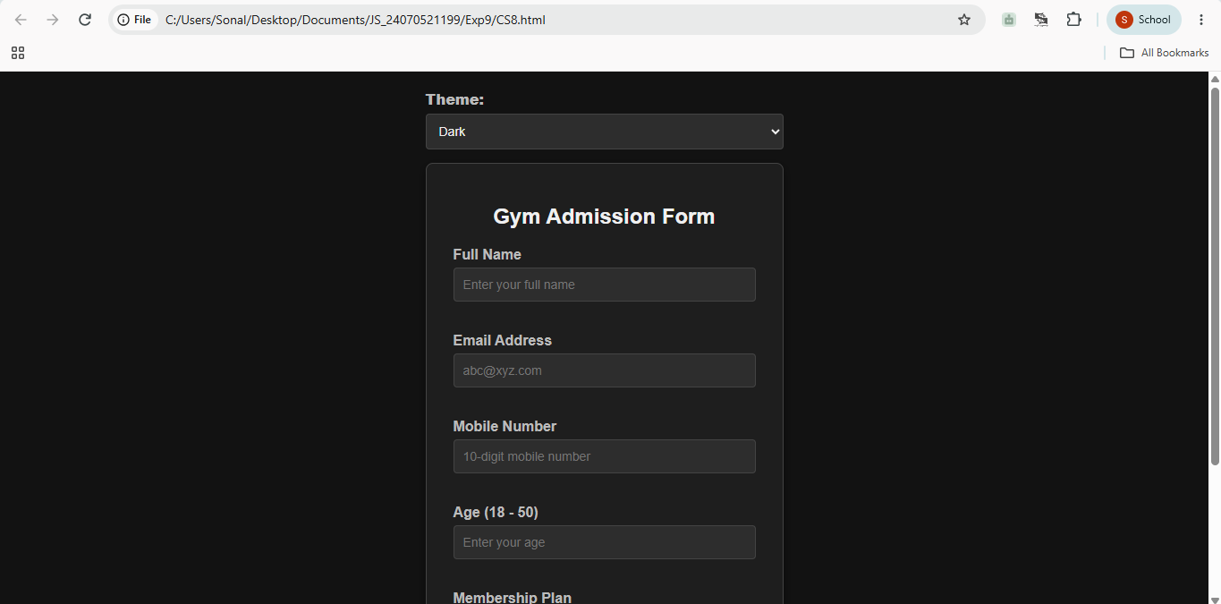
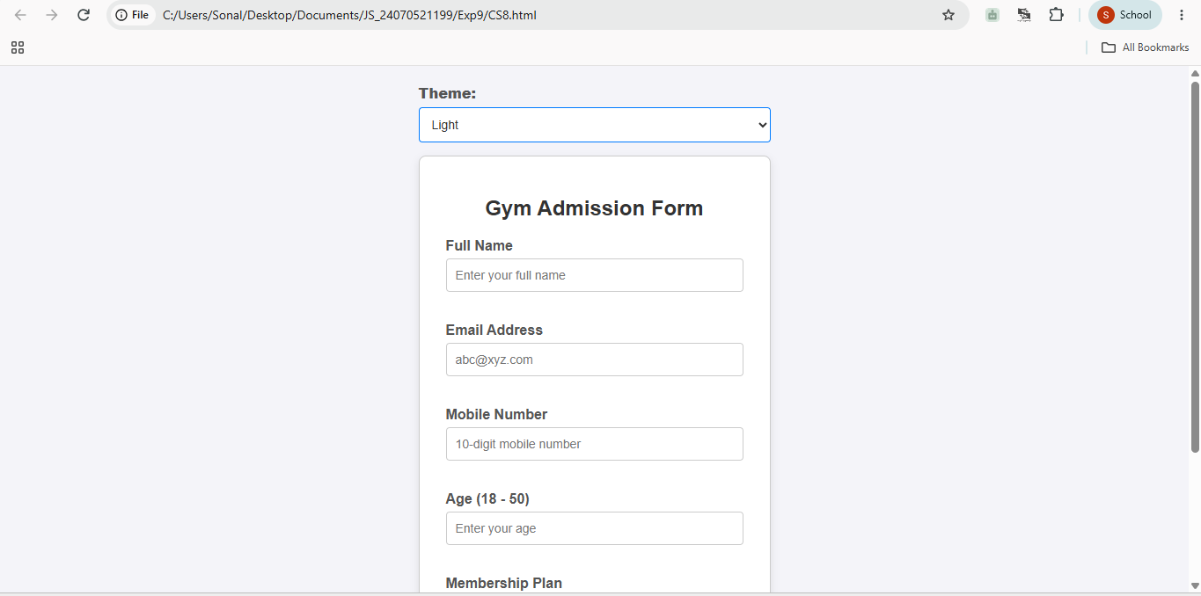

4. Result/Conclusion: Dynamic real-time form validation was successfully executed using input, change, and submit event listeners without forcing full page reloads.
Flexible theme switching was successfully integrated using CSS variables and JS-driven data-theme attribute manipulation on the root HTML element.

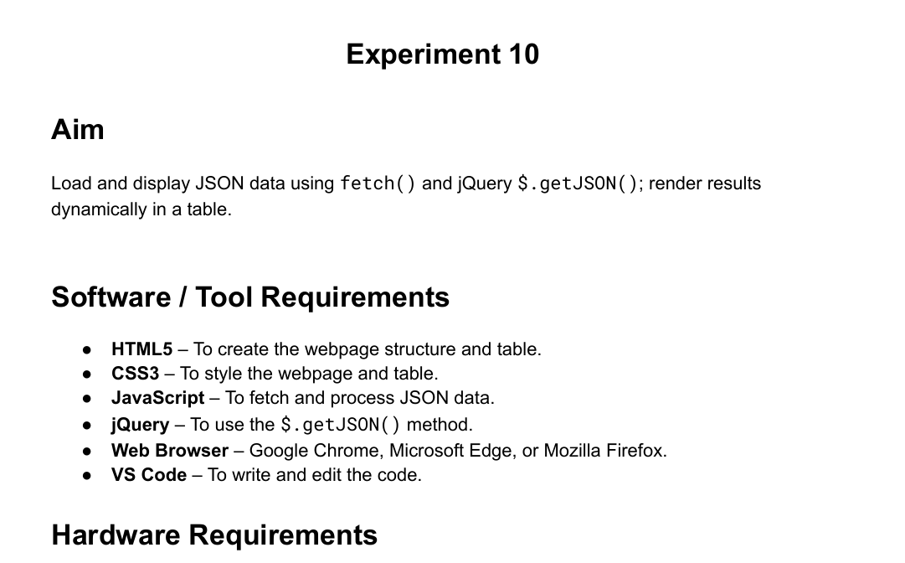
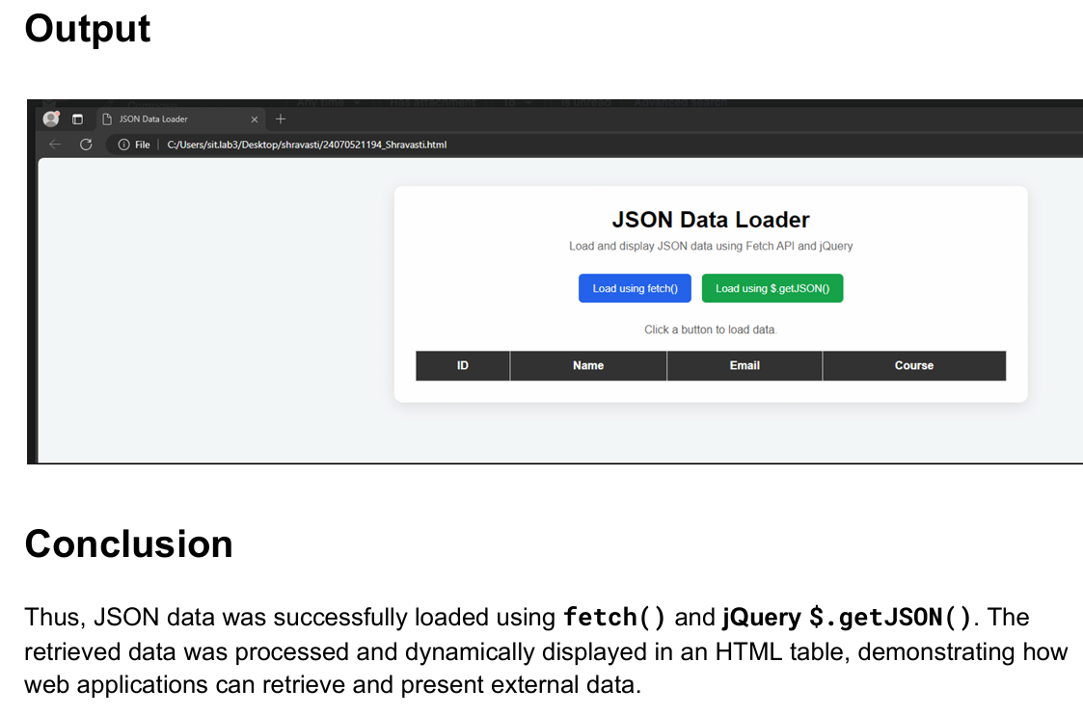

Case Study 8

<!DOCTYPE html>
<html lang="en">
<head>
<meta charset="UTF-8">
<meta name="viewport" content="width=device-width, initial-scale=1.0">
<title>Student Grade Calculator</title>
<style>
/* Hidden checkbox for theme toggling */
#theme-checkbox {
display: none;
}

/* --- LIGHT THEME (DEFAULT STYLE) --- */
.page-wrapper {
font-family: Arial, sans-serif;
background-color: #f4f6f9;
color: #333333;
min-height: 100vh;
display: flex;
flex-direction: column;
align-items: center;
padding-top: 40px;
box-sizing: border-box;
transition: background-color 0.3s, color 0.3s;
}

.theme-btn {
display: inline-block;
padding: 10px 20px;
background-color: #333333;
color: #ffffff;
border-radius: 5px;
cursor: pointer;
font-weight: bold;
margin-bottom: 20px;
user-select: none;
}

.calculator-box {
background-color: #ffffff;
border: 1px solid #dddddd;
border-radius: 10px;
padding: 30px;
width: 320px;
box-shadow: 0 4px 10px rgba(0,0,0,0.05);
text-align: center;
}

h2 {
margin-top: 0;
color: #0044cc;
}

.form-group {
margin-bottom: 20px;
text-align: left;
}

label {
display: block;
margin-bottom: 8px;
font-weight: bold;
font-size: 14px;
}

input {
width: 100%;
padding: 10px;
box-sizing: border-box;
border: 1px solid #cccccc;
border-radius: 4px;
background-color: #ffffff;
color: #333333;
font-size: 16px;
}

.calc-btn {
width: 100%;
padding: 12px;
background-color: #0044cc;
color: white;
border: none;
border-radius: 4px;
font-weight: bold;
font-size: 16px;
cursor: pointer;
}

.result-display {
margin-top: 20px;
font-size: 18px;
font-weight: bold;
min-height: 24px;
color: #222222;
}

/* --- DARK THEME STYLES (When Checked) --- */
#theme-checkbox:checked ~ .page-wrapper {
background-color: #121212;
color: #ffffff;
}

#theme-checkbox:checked ~ .page-wrapper .theme-btn {
background-color: #ffffff;
color: #333333;
}

#theme-checkbox:checked ~ .page-wrapper .calculator-box {
background-color: #1e1e1e;
border-color: #444444;
}

#theme-checkbox:checked ~ .page-wrapper h2 {
color: #bb86fc;
}

#theme-checkbox:checked ~ .page-wrapper input {
background-color: #2d2d2d;
border-color: #555555;
color: #ffffff;
}

#theme-checkbox:checked ~ .page-wrapper .calc-btn {
background-color: #bb86fc;
color: #121212;
}

#theme-checkbox:checked ~ .page-wrapper .result-display {
color: #ffffff;
}
</style>
</head>
<body>

<!-- Theme Controller Switch -->
<input type="checkbox" id="theme-checkbox">

<div class="page-wrapper">

<!-- Toggle Button -->
<label for="theme-checkbox" class="theme-btn">Change Theme</label>

<!-- Main UI Container -->
<div class="calculator-box">
<h2>Grade Checker</h2>

<div class="form-group">
<label for="marksInput">Enter Marks (0 - 100):</label>
<input type="number" id="marksInput" placeholder="e.g. 75" min="0" max="100">
</div>

<button type="button" class="calc-btn" onclick="checkGrade()">Check Grade</button>

<!-- Target Output Area -->
<div class="result-display" id="gradeOutput"></div>
</div>

</div>

<script>
function checkGrade() {
var marks = parseFloat(document.getElementById('marksInput').value);
var output = document.getElementById('gradeOutput');

if (isNaN(marks) || marks < 0 || marks > 100) {
output.innerText = "Please enter valid marks between 0 and 100.";
return;
}

// Grading logic threshold configuration
if (marks >= 75) {
output.innerText = "Grade: A";
} else if (marks >= 50) {
output.innerText = "Grade: B";
} else {
output.innerText = "Grade: C";
}
}
</script>

</body>
</html>

Output
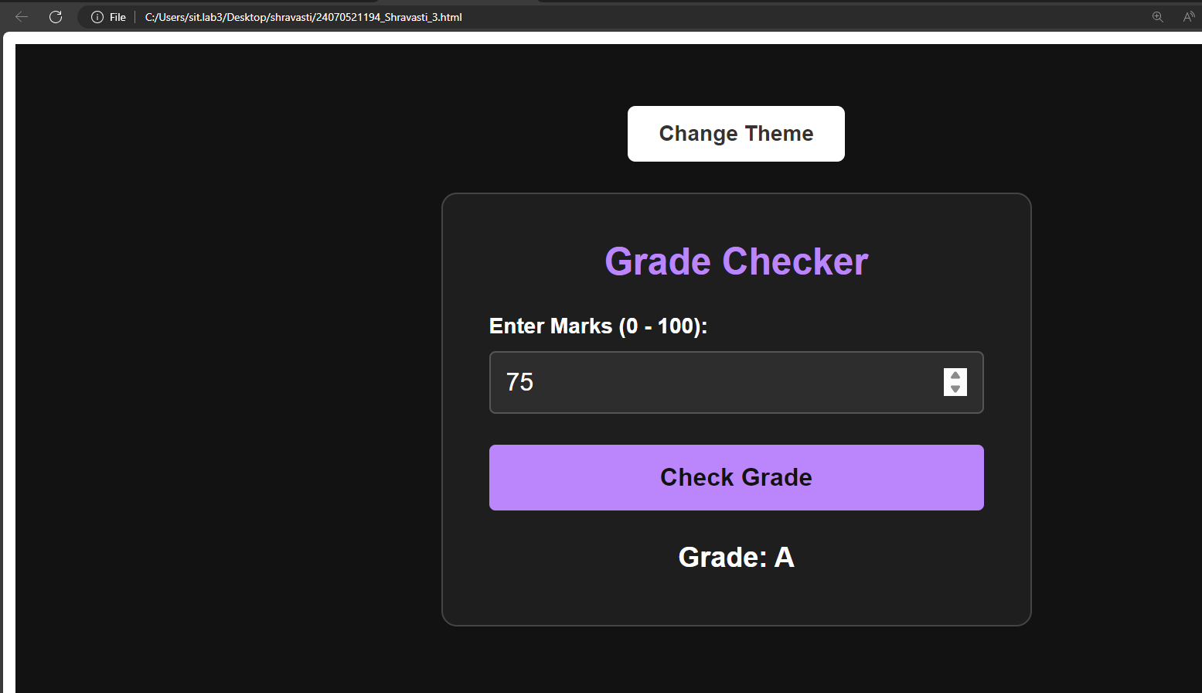

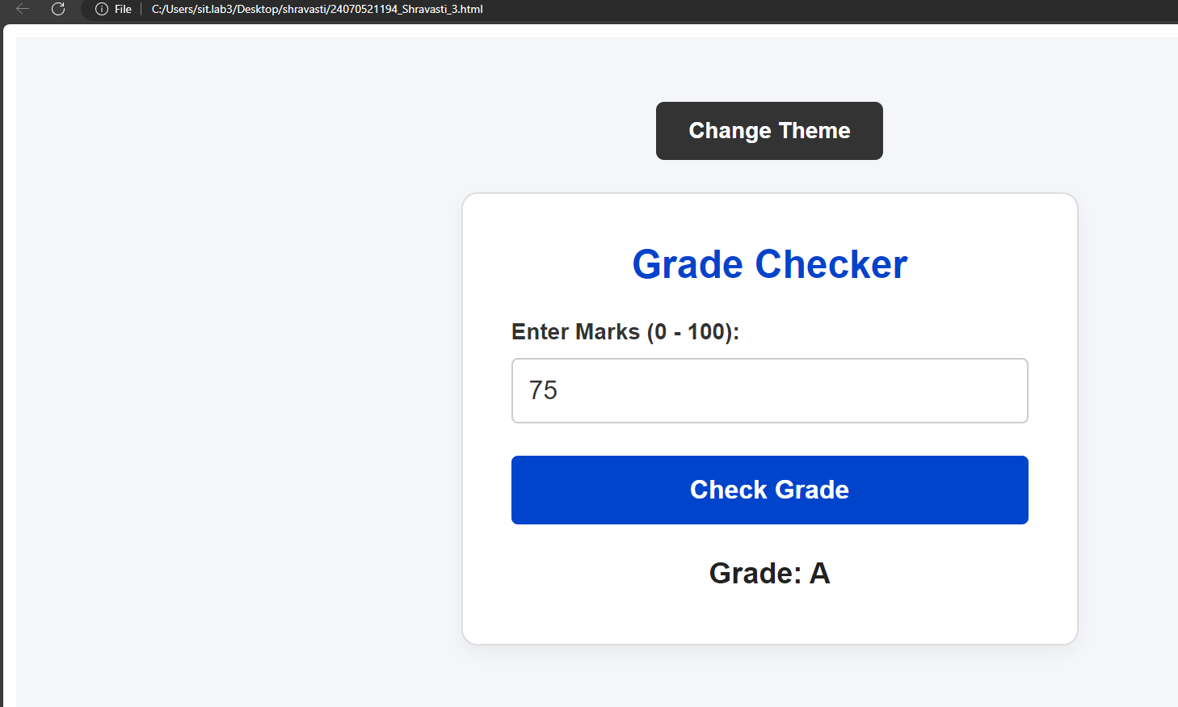

Case Study No.: 10

1. Case Study Title: A college maintains student registration data for various campus events in a JSON file. The event coordinator wants a web page that can load this information dynamically and display it in a table without manually entering the data. The student JSON file consists of Student Name, PRN, Department, Year, Event Name, and Registration Status (in a drop-down we can filter/search based on registered, pending, or cancelled) using fetch() and .$get. JSON(), display an appropriate message if JSON data cannot be loaded and no student matches the search/filter criteria.
2. Case Study Program Code:
/* shravasti 1194 */
<!DOCTYPE html>
<html lang="en">
<head>
<meta charset="UTF-8">
<meta name="viewport" content="width=device-width, initial-scale=1.0">
<title>Event Registration Table</title>

<!-- Include jQuery library for $.getJSON() capability -->
<script src="https://code.jquery.com/jquery-3.7.1.min.js"></script>

<style>
body {
font-family: Arial, sans-serif;
margin: 20px;
background-color: #f8f9fa;
color: #333;
}

h2 {
color: #222;
margin-bottom: 5px;
}

p.description {
color: #666;
font-size: 14px;
margin-top: 0;
margin-bottom: 20px;
}

/* Controls Bar Styling */
.controls {
background-color: #ffffff;
padding: 15px;
border: 1px solid #ccc;
border-radius: 6px;
margin-bottom: 15px;
display: flex;
gap: 15px;
align-items: center;
flex-wrap: wrap;
}

.control-group {
display: flex;
align-items: center;
gap: 8px;
}

label {
font-weight: bold;
font-size: 14px;
}

input[type="text"], select {
padding: 6px 10px;
border: 1px solid #ccc;
border-radius: 4px;
font-size: 14px;
}

button {
padding: 7px 12px;
background-color: #007bff;
color: white;
border: none;
border-radius: 4px;
cursor: pointer;
font-size: 14px;
}

button:hover {
background-color: #0056b3;
}

button.jquery-btn {
background-color: #28a745;
}

button.jquery-btn:hover {
background-color: #218838;
}

/* Error Alert Box */
.error-msg {
background-color: #f8d7da;
color: #721c24;
padding: 12px;
border: 1px solid #f5c6cb;
border-radius: 4px;
margin-bottom: 15px;
display: none;
font-size: 14px;
}

/* Table Styling */
table {
width: 100%;
border-collapse: collapse;
background-color: #ffffff;
border: 1px solid #ccc;
}

th, td {
padding: 10px;
text-align: left;
border: 1px solid #ddd;
font-size: 14px;
}

th {
background-color: #e9ecef;
}

tr:nth-child(even) {
background-color: #f9f9f9;
}

/* Plain Text Status Badge Styling */
.status-badge {
display: inline-block;
padding: 4px 8px;
font-size: 12px;
font-weight: bold;
border-radius: 4px;
}

.status-registered {
background-color: #d4edda;
color: #155724;
border: 1px solid #c3e6cb;
}

.status-pending {
background-color: #fff3cd;
color: #856404;
border: 1px solid #ffeeba;
}

.status-cancelled {
background-color: #f8d7da;
color: #721c24;
border: 1px solid #f5c6cb;
}

.no-results-td {
text-align: center;
color: #856404;
background-color: #fff3cd;
padding: 15px;
font-weight: bold;
}
</style>
</head>
<body>

<h2>Event Registration Table</h2>
<p class="description">Student event registration manager with real-time text search and status filter dropdown.</p>

<!-- Error message display area (hidden by default) -->
<div id="errorMessage" class="error-msg"></div>

<!-- Filter & Fetch Controls -->
<div class="controls">
<div class="control-group">
<label for="searchInput">Search:</label>
<input type="text" id="searchInput" placeholder="Search name, PRN, event...">
</div>

<div class="control-group">
<label for="statusFilter">Status Filter:</label>
<select id="statusFilter">
<option value="All">All Statuses</option>
<option value="Registered">Registered</option>
<option value="Pending">Pending</option>
<option value="Cancelled">Cancelled</option>
</select>
</div>

<button onclick="loadWithFetch()">Try Load via fetch()</button>
<button class="jquery-btn" onclick="loadWithJQuery()">Try Load via $.getJSON()</button>
</div>

<!-- Registration Table -->
<table>
<thead>
<tr>
<th>Student Name</th>
<th>PRN</th>
<th>Department</th>
<th>Year</th>
<th>Event Name</th>
<th>Registration Status</th>
</tr>
</thead>
<tbody id="studentTableBody">
<!-- Dynamically filled by JavaScript -->
</tbody>
</table>

<script>
// Default master dataset loaded directly on startup
const defaultStudents = [
{
"studentName": "Aarav Sharma",
"PRN": "2024PRN001",
"department": "Computer Science",
"year": "3rd Year",
"eventName": "AI Tech Summit",
"registrationStatus": "Registered"
},
{
"studentName": "Priya Patel",
"PRN": "2024PRN002",
"department": "Information Technology",
"year": "2nd Year",
"eventName": "Cyber Security Workshop",
"registrationStatus": "Pending"
},
{
"studentName": "Rohan Deshmukh",
"PRN": "2024PRN003",
"department": "Electronics",
"year": "4th Year",
"eventName": "Robotics League 2026",
"registrationStatus": "Cancelled"
},
{
"studentName": "Ananya Roy",
"PRN": "2024PRN004",
"department": "Computer Science",
"year": "1st Year",
"eventName": "CodeSprint Hackathon",
"registrationStatus": "Registered"
},
{
"studentName": "Vikram Singh",
"PRN": "2024PRN005",
"department": "Mechanical Eng.",
"year": "3rd Year",
"eventName": "CAD Expo",
"registrationStatus": "Pending"
}
];

// Current student list displayed in memory
let students = [...defaultStudents];

// Method 1: Load external file with standard fetch() API
function loadWithFetch() {
hideError();
fetch('students.json')
.then(response => {
if (!response.ok) {
throw new Error(`HTTP ${response.status}: Failed to locate 'students.json' file.`);
}
return response.json();
})
.then(data => {
students = data;
applyFilterAndSearch();
})
.catch(error => {
showError("Error loading 'students.json' via fetch(): " + error.message);
});
}

// Method 2: Load external file with jQuery $.getJSON() API
function loadWithJQuery() {
hideError();
$.getJSON('students.json')
.done(function(data) {
students = data;
applyFilterAndSearch();
})
.fail(function(jqxhr, textStatus, error) {
showError("Error loading 'students.json' via $.getJSON(): File not found or local browser restriction.");
});
}

// Filter table by text search and dropdown status
function applyFilterAndSearch() {
const searchText = document.getElementById('searchInput').value.toLowerCase().trim();
const selectedStatus = document.getElementById('statusFilter').value;

const filteredStudents = students.filter(student => {
const matchesSearch =
student.studentName.toLowerCase().includes(searchText) ||
student.PRN.toLowerCase().includes(searchText) ||
student.department.toLowerCase().includes(searchText) ||
student.eventName.toLowerCase().includes(searchText);

const matchesStatus = (selectedStatus === "All") || (student.registrationStatus === selectedStatus);

return matchesSearch && matchesStatus;
});

renderTable(filteredStudents);
}

// Render filtered student list into table rows
function renderTable(studentList) {
const tbody = document.getElementById('studentTableBody');
tbody.innerHTML = "";

// Message when search or filter returns zero records
if (studentList.length === 0) {
tbody.innerHTML = `
<tr>
<td colspan="6" class="no-results-td">
No student matches the search/filter criteria.
</td>
</tr>`;
return;
}

studentList.forEach(student => {
let statusClass = '';
if (student.registrationStatus === 'Registered') statusClass = 'status-registered';
else if (student.registrationStatus === 'Pending') statusClass = 'status-pending';
else if (student.registrationStatus === 'Cancelled') statusClass = 'status-cancelled';

const row = document.createElement('tr');
row.innerHTML = `
<td>${student.studentName}</td>
<td>${student.PRN}</td>
<td>${student.department}</td>
<td>${student.year}</td>
<td>${student.eventName}</td>
<td>
<span class="status-badge ${statusClass}">${student.registrationStatus}</span>
</td>
`;
tbody.appendChild(row);
});
}

function showError(message) {
const errBox = document.getElementById('errorMessage');
errBox.textContent = message;
errBox.style.display = 'block';
}

function hideError() {
const errBox = document.getElementById('errorMessage');
errBox.style.display = 'none';
}

// Attach event listeners for search box and status dropdown
document.getElementById('searchInput').addEventListener('input', applyFilterAndSearch);
document.getElementById('statusFilter').addEventListener('change', applyFilterAndSearch);

// Initial page startup: render table immediately from default array
window.onload = function() {
applyFilterAndSearch();
};
</script>
</body>
</html>

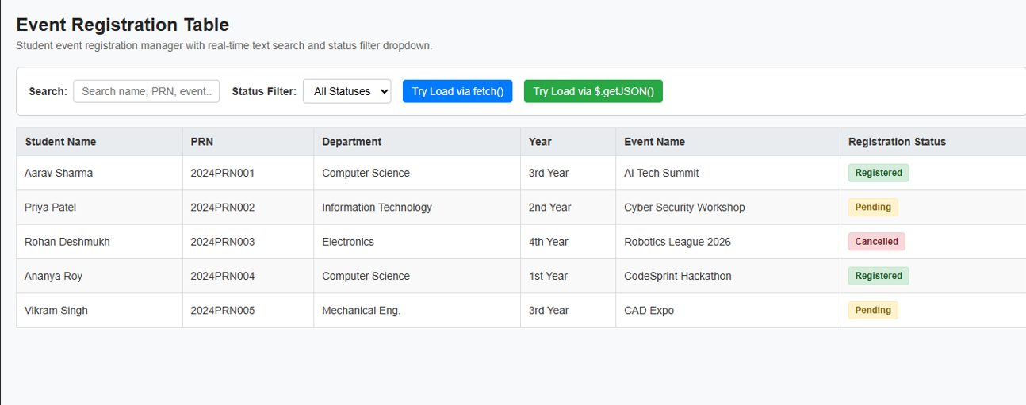

4. Result/Conclusion: This event registration web page delivers a simple, lightweight solution for event coordinators to manage student records dynamically without manual data entry.
Key Highlights:
- Flexible Data Handling: Supports both standard Vanilla JavaScript (fetch()) and jQuery ($.getJSON()) for dynamic loading, pre-loaded with fallback sample data to eliminate initial loading errors.
- Streamlined Filtering: Features real-time text search and a dedicated status dropdown (Registered, Pending, Cancelled) in the top filter bar for instant record lookup.
- Clean Table Layout: Displays student details—Name, PRN, Department, Year, Event Name, and Registration Status—as readable text badges instead of cluttered form inputs.
- Robust Error & Empty States: Provides clear, contextual alerts only when external file fetches fail or when search/filter combinations return no matching records.

